

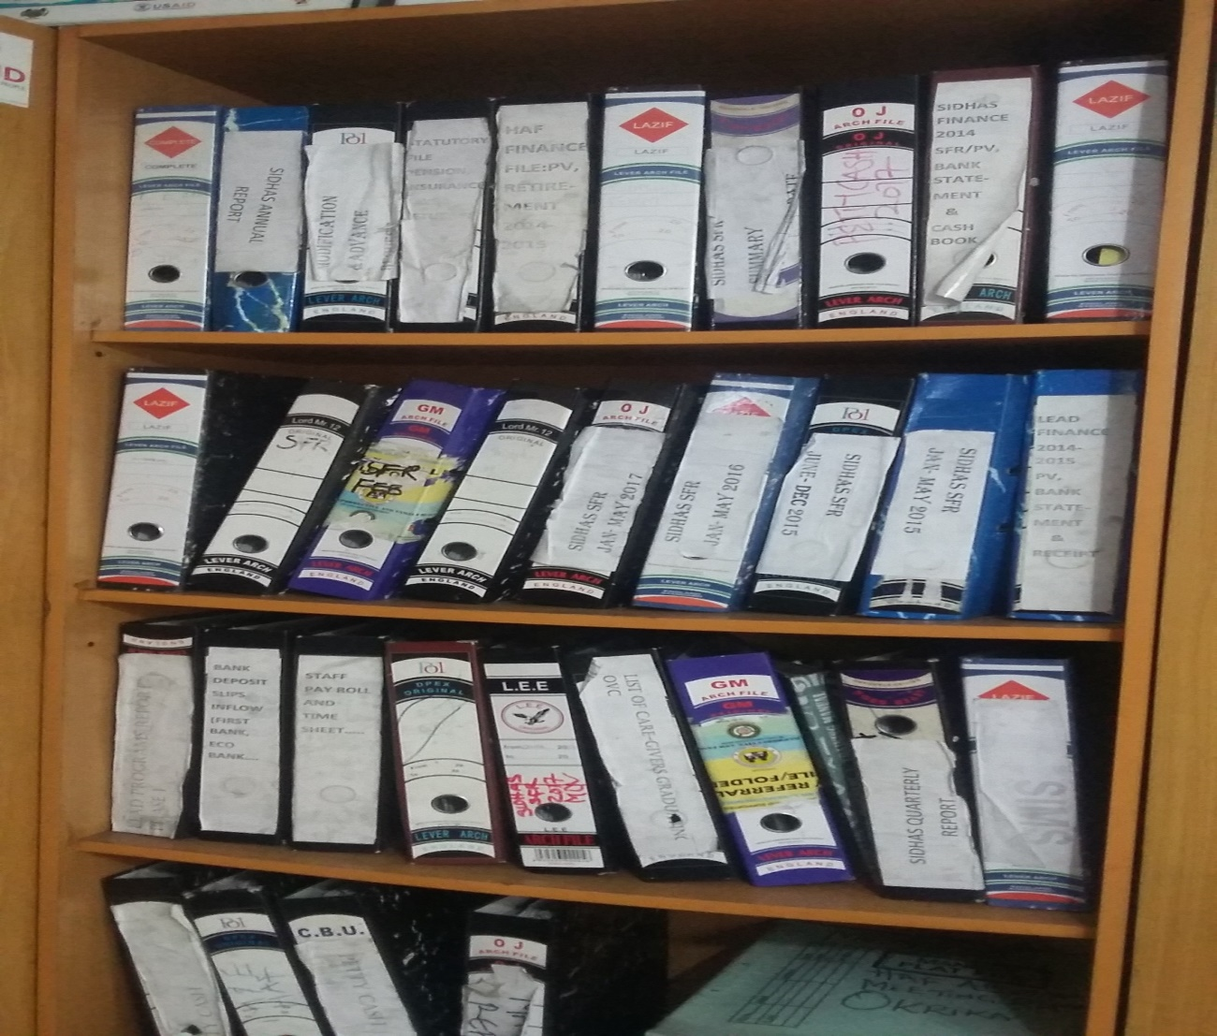

IFEYINWA ARINZE FOR DEVTECH systems, inc. / USAID

**FY 2018 Data Quality Assessment**

IFEYINWA ARINZE, FOR DEVTECH SYSTEMS, INC. / USAID

Strengthening Integrated Delivery of HIV/AIDS Services (SIDHAS) - Orphans and Vulnerable Children (OVC)

Family Health International 360 (FHI 360)

Report Submitted: October 2, 2018

*This page is intentionally left blank.*

CONTENTS

ACRONYMS vii

1 EXECUTIVE SUMMARY 1

1.1 INTRODUCTION, PURPOSE AND METHODOLOGY 1

1.2 FINDINGS 2

1.3 ACTION POINTS 4

2 Introduction and purpose of the DQA 5

2.1 DATA QUALITY STANDARDS 6

2.2 OBJECTIVES OF THE DQA 6

2.3 INDICATORS ASSESSED 7

2.3.1 OVC_SERV 7

2.3.2 OVC_HIVSTAT 7

2.4 PERIOD OF THE DQA 8

2.5 THE SIDHAS ACTIVITY 8

3 METHODOLOGY 11

3.1 SAMPLING METHODOLOGY FOR SITE SELECTION 11

3.1.1 INCLUSION CRITERIA: 11

3.1.2 EXCLUSION CRITERIA: 12

3.2 SAMPLE SIZE 12

3.3 SELECTION OF BENEFICIARY FOLDERS AND FORMS FOR OVC INDICATOR REVIEW AT SITES 13

3.4 DATA COLLECTION FOR VALIDATION OF THE SELECTED INDICATORS 14

3.4.1 M&E SYSTEMS ASSESSMENT 14

3.4.2 DATA VERIFICATION 14

3.4.3 DEFINITION AND INTERPRETATION OF THE VERIFICATION FACTOR 15

3.4.4 METHODOLOGY FOR CROSS-CHECKS AT THE CBO LEVEL 15

3.5 DQA TOOL 16

3.6 OTHER OPERATIONAL CONSIDERATIONS FOR DQAS 17

3.7 DATA ANALYSIS 18

4 FINDINGS 19

4.1 M&E SYSTEMS ASSESSMENT – SIX FUNCTIONAL AREAS 19

4.1.1 SIDHAS CENTRAL M&E UNIT 19

4.1.2 SIDHAS STATE M&E UNIT 21

4.1.3 SIDHAS SERVICE DELIVERY LEVEL (CBOS) 24

4.2 DATA QUALITY STANDARDS 27

4.2.1 VALIDITY 27

4.2.2 INTERGRITY 33

4.2.3 PRECISION 34

4.2.4 RELIABILITY 34

4.2.5 TIMELINESS 35

5 ACTION PLAN FOR SIDHAS OVC 36

5.1 ACTION PLAN FOR SIDHAS OVC CENTRAL LEVEL 36

5.2 ACTION PLAN FOR SIDHAS OVC STATE LEVEL 37

5.3 ACTION PLAN FOR SIDHAS OVC CBO LEVEL 38

6 Limitations and Constraints 39

7 CONCLUSION 40

8 Annexes 41

8.1 LIST OF SITES VISITED AND LOCATIONS: SIDHAS OVC DQA 41

8.2 STEPS FOR DATA VERIFICATION USING THE MEASURE EVALUATION TOOL 41

8.3 VERIFICATION FACTORS FOR SIDHAS OVC CENTRAL, STATE AND CBO LEVELS 42

8.4 DATA BACKUP MECHANISMS IN ANAMBRA, AKWA IBOM, LAGOS AND RIVERS CBOS 47

8.5 DIAGRAMMATIC REPRESENTATION OF CROSS-CHECKS AT CBO LEVEL 48

8.6 PERFORMANCE INDICATOR REFERENCE SHEET (PIRS) 49

8.7 LIST OF DOCUMENTS, DATA AND STANDARD OPERATING PROCEDURES REVIEWED 56

8.7.1 LIST OF SIDHAS OVC DATA DOCUMENTS REVIEWED 56

8.7.2 LIST OF SIDHAS TOOLS REVIEWED 56

8.7.3 LIST OF SIDHAS SOP/GUIDELINES AND OTHER DOCUMENTS REVIEWED 56

8.8 LIST OF INDIVIDUALS INTERVIEWED DURING THE SIDHAS OVC DQA 57

LIST OF TABLES

Table 1. Data Quality Standards and Operational Definitions 6

Table 2. Schedule for SIDHAS OVC DQA 8

Table 3. List of Central, State, and CBO Offices/Sites Visited for the SIDHAS OVC DQA 12

Table 4. Data Coverage for SIDHAS OVC DQA, by Level 13

Table 5. Cross Check Findings from SIDHAS CBOs in Anambra, Akwa Ibom, Lagos and Rivers States for OVC_SERV 31

Table 6 Cross Check Findings from SIDHAS CBOs in Anambra, Akwa Ibom, Lagos and Rivers for OVC_HIVSTAT 32

Table 7. Mechanisms used to ensure data integrity across SIDHAS OVC sites 33

Table 8. Action Plan for SIDHAS OVC Central Level 36

Table 9. Action Plan for SIDHAS OVC State Level 37

Table 10. Action Plan for SIDHAS OVC CBO Level 38

Table 11. Verification Factors - OVC_SERV at SIDHAS OVC Central Level 42

Table 12. Verification Factors - OVC_SERV at SIDHAS OVC State and CBO levels 42

Table 13. OVC_HIVSTAT Numerator Total and Disaggregate Data at the Central, State and CBO Levels 43

Table 14. Verification Factors: OVC_HIVSTAT Numerator Total and Disaggregate Data at the Central, State and CBO Levels 45

Table 15. Data Backup Mechanisms Utilized in SIDHAS CBOs Visited 47

Table 16: Performance Indicator Reference Sheet for OVC_SERV 49

Table 17. Performance Indicator Reference Sheet for OVC_HIVSTAT 52

Table 18. List of Individuals Interviewed during the SIDHAS OVC DQA 57

LIST OF FIGURES

Figure 1: Global Average – SIDHAS Data Management System Assessment 3

*Figure 2. Dovetailing of the SIDHAS Activity Outcomes: GHAIN versus SIDHAS* 9

*Figure 3. SIDHAS Coverage in Nigeria* 9

*Figure 4. Implementation Strategies for SIDHAS* 10

*Figure 5. Spider Graph of M&E Systems Assessment - SIDHAS Central M&E Unit* 20

*Figure 6. Spider Graph of SIDHAS OVC M&E Systems Assessment: Anambra State* 23

Figure 7: Spider Graph of SIDHAS OVC M&E Systems Assessment: Akwa Ibom State 23

*Figure 8. Spider Graph of SIDHAS OVC M&E Systems Assessment: Lagos State* 23

Figure 9: Spider Graph of SIDHAS OVC M&E Systems Assessment: Rivers State 24

Figure 10. Data Verification by level of reporting of SIDHAS OVC sites: OVC_SERV 29

Figure 11: Data Verification by level of reporting of SIDHAS OVC sites: OVC_HIVSTAT 29

Figure 12. Data Verification factor by CBOs (OVC_SERV and OVC_HIVSTAT) 30

Figure 13. Reporting Performance – Results for SIDHAS OVC sites 35

Figure 14. Tracing & Verifying Reported Totals: CBO via State to Central M&E Unit 41

Figure 15. Methodology for Cross-Checks at CBO Level 48

# ACRONYMS

ADS Automated Directives System

ART Anti-Retroviral Therapy

AMELP Activity Monitoring, Evaluation and Learning Plan

BLYSN Blissful Life for Youth Society of Nigeria

CBO Community-Based Organization

CMP Change Management Process

CQI/TA Continuous Quality Improvement/Technical Assistance

CSI Child Status Index

CV Community Volunteers

DATIM Data for Accountability, Transparency, and Impact

DEC Data Entry Clerk

DME Director Monitoring and Evaluation

DQA Data Quality Assessment

FCT Federal Capital Territory

FG Federal Government

FHI 360 Family Health International 360

GHAIN Global HIV/AIDS Initiative Nigeria

GLAD GLAD Foundation

GoN Government of Nigeria

HFFPD Humanity Family Foundation for Peace and Development

HIV/AIDS Human Immunodeficiency Virus/Acquired Immunodeficiency Syndrome

IM Implementing Mechanism

IP Implementing Partner

JAKIN JAKIN NGO

LACA Local Action Committee on AIDS

LGA Local Government Authority (or Area)

LOPIN Local OVC Partners in Nigeria

M&E Monitoring and Evaluation

MEASURE Monitoring and Evaluation to Assess and Use Results

MEL Monitoring, Evaluation, and Learning

MER Monitoring, Evaluation, and Reporting

MWASD Ministry of Women’s Affairs and Social Development

NOMIS National OVC Management Information System

NPC National Population Commission

OGAC Office of the United States Global AIDS Coordinator

OVC Orphans and Vulnerable Children

OVC_HIVSTAT PEPFAR Indicator: Number of children less than 18 years with reported HIV status to implementing partner

OVC_SERV PEPFAR Indicator: Number of beneficiaries served by PEPFAR OVC programs for children and families affected by HIV

PEPFAR President’s Emergency Plan for AIDS Relief

PIRS Performance Indicator Reference Sheet

PMP Performance Monitoring Plan

PMT Project Management Team

PMTCT Prevention of Mother to Child Transmission

RDQA Routine Data Quality Assessment

SAPR Semi Annual Program Results

SHERO Support Health Redemption Organization

SIDHAS Strengthening Integrated Delivery if HIV/AIDS Services

SMDI Support for Mankind Development Initiative (SMDI)

SMILE Sustainable Mechanism for Improving Livelihoods and Household Empowerment

SMWASD State Ministry of Women Affairs and Social Development

SOP Standard Operating Procedure(s)

SPM State Program Manager

SPO State Program Officer

STEER Systems Transformed for Empowered Action and Enabling Responses for Vulnerable Children and Families

STO State Technical Officer

TB Tuberculosis

TWG Technical Working Group

USAID United States Agency for International Development

VC Vulnerable Children

WOCLIF Women Community Livelihood Foundation

YPF Youth Pro_File

# EXECUTIVE SUMMARY

## INTRODUCTION, PURPOSE AND METHODOLOGY

The United States Agency for International Development (USAID)/Nigeria technical offices regularly collect performance data from their Implementing Partners (IPs) and analyze them to make management decisions. Program management requires accurate, reliable, complete, and timely data to facilitate evidence-based decision making. Orphans and Vulnerable Children (OVC) programs among Human Immunodeficiency Virus, Acquired Immunodeficiency Syndrome (HIV/AIDS) affected populations provide need-based and age-appropriate socioeconomic interventions and require data that ensures provision of high-quality services. Since poor-quality data affect conclusions about performance and lead to incorrect decisions, USAID requires that all Missions/Offices conduct regular Data Quality Assessments (DQAs), to review (1) strengths and weaknesses of the data, as determined by applying the five data quality standards (i.e., **validity, reliability, timeliness, precision and integrity**), and (2) the extent to which data integrity can be trusted in making management decisions.

The Strengthening Integrated Delivery of HIV/AIDS Services (SIDHAS) Activity is one of the USAID/Nigeria’s OVC Implementing Mechanisms (IMs) being implemented by the Family Health International 360 (FHI 360). In June 2018, USAID/Nigeria and the Monitoring, Evaluation, and Learning (MEL) Activity of DevTech Systems, Inc. conducted a joint DQA exercise to review performance data submitted by SIDHAS to USAID for the period October 1, 2017, to March 31, 2018 for two President’s Emergency Plan for AIDS Relief (PEPFAR) indicators, “OVC_SERV” and “OVC_HIVSTAT”. OVC_SERV is the “number of beneficiaries served by PEPFAR OVC programs for children and families affected by HIV” and OVC_HIVSTAT is the “percentage of OVC (less than 18 years old) with HIV status reported to IP (including status not reported), disaggregated by status type”. The denominator is no longer collected as part of the OVC_HIVSTAT indicator. The denominator is collected as part of the OVC_SERV indicator.

The DQA was implemented using a purposive sampling methodology in eleven selected Community Based Organizations (CBOs) in Anambra, Akwa Ibom, Lagos and Rivers states, the respective SIDHAS state offices, and the SIDHAS central Monitoring and Evaluation (M&E) unit in Abuja. The DQA methodology at all levels included: (1) A review of activity M&E documents, materials, and data, including Standard Operating Procedures (SOP), guidelines, Performance Indicator Reference Sheet (PIRS), and other guiding documents for organizational M&E management, data management, and processing; (2) A review of six months of SIDHAS OVC summary reports, and trace and verification of data for the two indicators, (including National OVC Management Information System [NOMIS] data); (3) A review of a subset of source documents (beneficiary forms and household folders), and entries of beneficiaries and households data in the NOMIS; (4) Interviews with M&E officers and personnel; (5) Cross-checks across systems and records; (6) A review of the data applying the five data quality standards (i.e., validity, reliability, integrity, precision and timeliness); and (7) A debrief at each site on the preliminary DQA findings using a feedback form. The DQA team utilized the USAID MEASURE Evaluation’s DQA Excel Tool (RDQA multi-indicator version,[1] as well as the USAID DQA checklist[2] to assess the data quality standards.

## FINDINGS

**M&E Systems Assessment**

SIDHAS Central M&E Unit: *Strengths*: (1) Responsibility for data review at the central level has been assigned to specific members of the M&E team; (2) The SOP on data management includes clear steps for data aggregation, quality checks, and feedback to states on observed data discrepancies; and (3) Availability of in-house information technology capacity for NOMIS. *Areas for Improvement*: Nil. *Recommendations*: Nil.

SIDHAS State M&E Units: *Strengths*: (1) All state-level M&E Officers have received relevant training to carry out their assigned responsibilities; (2) The PIRS for the indicators and data management SOP were available and in use to guide activity implementation; (3) Availability and use of NOMIS database for reporting; and (4) Use of data for decision making in all the four states. *Areas for Improvement*: Few charts developed using OVC indicator data at the SIDHAS Akwa Ibom State office. *Recommendation*: Develop and disseminate more findings from analyzed data to key stakeholders using OVC indicator data (in Akwa Ibom state).

SIDHAS CBOs: *Strengths*: (1) CBOs use a variety of methods to minimize data quality issues and prevent double counting such as data reviews and use of the NOMIS; (2) Other staff members of CBOs trained in M&E fill-in the gap for the M&E Officer when unavailable; (3) Availability and use of PIRS and SOP to guide activity implementation; (4) Regular feedback is provided to CBOs on data submitted to the SIDHAS state M&E team; (5) Beneficiary folders are stored under lock and key with limited access; (6) Data are backed up routinely using external drive and the cloud; and (7) Data are analyzed and disseminated to various stakeholders for decision making. *Areas for Improvement*; (1) Arrangement of beneficiary folders in horizontal position instead of vertical position made retrieval difficult at Humanity Family Foundation for Peace and Development (HFFPD) and at Support Health Redemption Organization (SHERO); (2) The use of outdated VC service forms by CBOs in Akwa Ibom state; (3) Numerous cancellations on service forms with correction fluid observed at CBOs in Akwa Ibom state; and (4) Inconsistent data back-up at SHERO CBO. *Recommendations:* (1) Provide capacity building for CBO staff on the proper arrangement of beneficiary folders for easy retrieval (HFFPD and SHERO CBOs); (2) Discourage the use of outdated VC service forms and encourage the use of updated forms across all CBOs in Akwa Ibom state; (3) Provide refresher training for CBO CVs in Akwa Ibom state on how to properly fill data collection tools; and (4) Encourage consistent monthly data back-up at SHERO CBO.

The general findings on the M&E system assessment for all the three SIDHAS OVC levels are shown on the spiderweb graph in Figure 1 below. The area in need of improvement in the M&E system is the linkage of indicator data with the national reporting system, which is as a result of the parallel reporting channels i.e., to the Nigerian government and to USAID/Nigeria. However, there are mechanisms in place to harmonize data reported to both entities through the data harmonization meetings at the national and state levels, attended by various OVC activity implementers and the Government of Nigeria staff.

Figure 1: Global Average – SIDHAS Data Management System Assessment

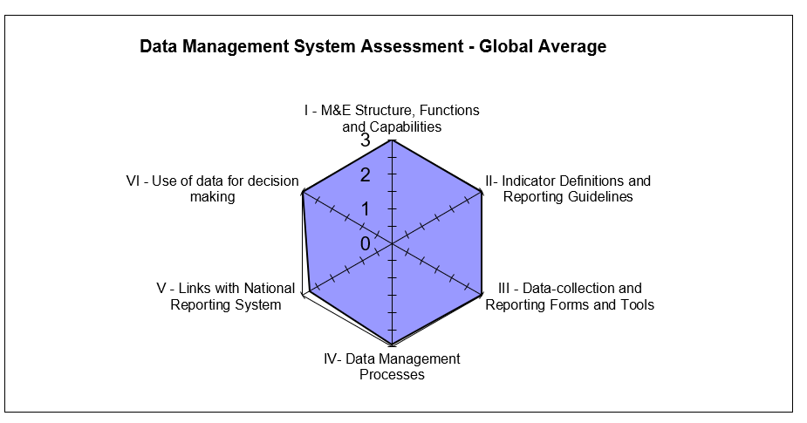

**Data Quality Standards**

Validity*:* *Strengths:* (1) The data collection process adheres to the PIRS requirements for the two indicators; (2) Data are reported consistently in all CBOs for vulnerable children less than18 years and their family members; and (3) The HIV status update form available on the NOMIS for recording current beneficiary HIV status. *Areas for Improvement:* Incomplete, incorrect and missing entries noted in the source documents and transcription errors were observed in the NOMIS. Reasons observed for the errors include inability to carry out real time data entry into the NOMIS and poor supervision of the DECs and CVs. *Recommendations:* (1) Strengthen the data review process before and after data entry into the NOMIS to reduce data entry errors; (2) Conduct refresher training for CVs on completion of service forms; (3) Improve supervisory efforts with CVs and DEC to ensure accurate data entry; and (4) Conduct periodic folder audits to ensure that the information in the paper base service form is in concordance with the data in the NOMIS.

Integrity*:* *Strengths:* (1) Data quality assurance and management conducted at the central and state levels are through: (a) The use of the NOMIS software which has password access for confidentiality and built-in error and quality checks; (b) Conduct of visits to lower reporting levels for supervision and data quality checks; and (c) The use of e-mail and phone call communication by the M&E staff; and (2) Data review meetings during which data quality issues are addressed. *Areas for Improvement:* Multiple cancellations on the service forms using correction fluid at CBOs in Akwa Ibom state. *Recommendations* (1) Conduct capacity building for CVs on proper filling of the service forms to avoid multiple entry errors; and (2) Ensure proper documentation of all data changes/ corrections to data in the data collection tools. This should include (but not limited to) the reason for the change and the authorizing officer granting the change.

Precision. *Strengths*: (1) The NOMIS has individual-level data, providing sufficient detail and precision on beneficiary and number of children less than 18 years with HIV status reported to the IP; (2) The level of precision in the data collection tools and in the NOMIS matches the requirements in the PIRS; and (3) Data from service forms are entered in the NOMIS in a consistent manner using all nationally approved data fields. *Areas for Improvement:* None. *Recommendations:* There were no specific recommendations in connection with data precision.

Reliability*:* *Strengths*: (1) National OVC reporting tools were consistently used during the reporting period; (2) All CBO staff have been trained on the updated OVC tools and none experienced stock out of tools during the period under review. *Areas for Improvement:* Use of outdated VC forms by CBOs in Akwa Ibom state. *Recommendations:* Ensure compliance to the use of updated OVC reporting tools across all CBOs.

Timeliness*:* *Strengths*: (1) Data reporting from CBO level upward is electronic, via NOMIS and was reported timely to USAID for the SAPR reporting period. *Areas for Improvement:* Untimely submission of reports from SIDHAS state offices and CBOs in Anambra and Akwa Ibom states. *Recommendations:* Ensure compliance of SIDHAS state and CBO offices to reporting timelines.

## ACTION POINTS

*Central Level*: Monitor the reporting frequency of state office reports and ensure compliance of state offices to reporting timelines.

*State Level*: (1) Develop and disseminate findings from analyzed data to key stakeholders using OVC indicator data (in Akwa Ibom state); (2) Provide capacity building to CBO staff on the proper arrangement of beneficiary folders for easy retrieval (HFFPD and SHERO); (3) Discourage the use of outdated VC service forms and encourage the use of only updated OVC reporting tools across all CBOs in Akwa Ibom state; (4) Improve supervisory efforts with the CBOs to ensure accurate data entry and proper use of the NOMIS; (5) Conduct refresher training for CVs on completion of service forms and DECs on the NOMIS software; (6) Ensure all CBOs conduct data quality cross checks between NOMIS soft copy data and a hard copy Excel NOMIS data before reporting; and (7) Provide support to CBO M&E officers to conduct periodic folder audits to resolve discrepancies observed during cross checks.

*CBO Level*: (1) Provide refresher training to CBO CVs in Akwa Ibom state on how to properly fill data collection tools; and (2) Ensure consistent monthly data back-up at SHERO CBO.

With reference to the Automated Directive System (ADS) 201 definition of data quality standards (Table 1), the OVC_SERV and OVC_HIVSTAT indicator data reported by SIDHAS can be judged valid. The overall IP verification factor average was 100 percent, which falls within the +/- ten percent acceptable variance for determining the accuracy of verified data. The validity of the data for the two indicators can be improved by strengthening supervisory efforts at the state offices and CBO as well as the data review process at the CBO. Data was also found to be reliable, precise and have integrity. Timeliness can be improved by ensuring compliance of state and CBO levels to reporting timelines.

# Introduction and purpose of the DQA

The United States Agency for International Development (USAID)/Nigeria technical offices regularly collect performance data from their Implementing Partners (IPs), and analyze it to make management decisions. Program management requires accurate, reliable, complete, and timely data to facilitate evidence-based decision-making and, ultimately, to ensure efficient and effective program implementation. Orphan and Vulnerable Children (OVC) programs among populations affected by Human Immunodeficiency Virus, Acquired Immunodeficiency Syndrome (HIV/AIDS) provide socioeconomic interventions that are need based and age appropriate, and therefore require data to ensure that high-quality services are provided to children and their families. This is even more important in households with an HIV-positive child or caregiver, who will need to receive the appropriate support to access care, treatment, and other related services. Since poor-quality data could affect conclusions about performance and lead to incorrect decisions, USAID requires that all Missions/Offices conduct regular Data Quality Assessments (DQA).

The Automated Directives System (ADS) contains the organization and functions of USAID, along with the policies and procedures that guide the Agency's programs and operations. As shown in ADS 201, the purpose of a DQA is to ensure that USAID Missions are aware of the:

1. Strengths and weaknesses of the data, as determined by applying the five data quality standards (Table 1 below); and
2. Extent to which the data integrity can be trusted in making management decisions. (ADS 201.3.5.8).

One of the primary purposes of the DQA presented in this report is to meet the ADS-related requirements of USAID/Washington and the USAID/Nigeria Technical Offices. A DQA also serves to review the Monitoring and Evaluation (M&E) system, supports the identification of best practices, and develops recommendations to improve existing systems, for better reporting of activity-level indicators in subsequent funding cycles.

The President’s Emergency Plan for AIDS Relief (PEPFAR) Nigeria implements its OVC activities through community-based partners and, in some cases, through comprehensive treatment partners who provide some OVC services. Most OVC Implementing Mechanisms (IMs) work through Community-Based Organizations (CBOs) that work directly with the communities although in some cases IPs conduct direct implementation to beneficiaries. Performance results are reported semi-annually based on the Office of the Global AIDS Coordinator (OGAC) requirements, and quarterly based on USAID requirements.

A joint DQA was conducted in the month of June 2018 by USAID/Nigeria and the Monitoring, Evaluation and Learning (MEL) Activity of DevTech Systems, Inc., to validate six months of performance data generated through the Strengthening Integrated Delivery of HIV/AIDS Services (SIDHAS) Activity implemented by the Family Health International 360 (FHI 360), one of USAID/Nigeria’s OVC IMs. The DQA was for the “OVC_SERV” and “OVC_HIVSTAT” PEPFAR indicators, as reported through the National OVC Management Information System (NOMIS) between October 1, 2017 and March 31, 2018. The SIDHAS OVC DQA was conducted at the central IP office in Abuja, four state offices and eleven selected CBOs; two in Anambra state, three in Akwa Ibom state, three in Lagos and three in Rivers state, with guidance from USAID and using purposive sampling methodology.

## DATA QUALITY STANDARDS

Table 1 lists the five data quality standards that are central to a DQA, especially in the context of USAID-funded activities.

Table 1. Data Quality Standards and Operational Definitions

|  |  |
| --- | --- |
| Data Quality Standard | Operational Definition |
| Validity | Data are valid to the extent that they clearly, directly and adequately represent the result that was intended to be measured. Measurement errors, unrepresentative sampling and simple transcription errors may adversely affect data validity. Data should be periodically tested to ensure that no error creates significant bias. |
| Reliability | Data reflect stable and consistent data collection processes and analysis methods over time. Activity managers are confident that progress toward performance targets reflects real changes rather than variations in data collection methods. Reliability can be affected by questionable validity as well as by changes in data collection processes. |
| Timeliness | Data are available with enough frequency and should be sufficiently current to inform management decision-making. Effective management decisions depend upon regular collection of up-to-date performance information. |
| Precision | Data should be sufficiently accurate to present a fair picture of performance and enable activity managers to make confident decisions. |
| Integrity | Data that are collected, analyzed and reported should have a mechanism in place to reduce the possibility that data are subject to erroneous or intentional alteration. |

Source: ADS 201. Data Quality Assessment Standards.

## OBJECTIVES OF THE DQA

In addition to the overall purpose of the DQA mentioned in ADS 201, the specific objectives of the DQA are to:

1. Verify that the quality of data reported from October 1, 2017 to March 31, 2018 for the OVC_SERV and OVC_HIVSTAT indicators, by the SIDHAS OVC Activity (section 2.5), are grounded in the components of data quality.
2. Ensure that managers can use data generated to effectively direct available resources, and to evaluate progress toward established goals.
3. Assess and identify potential challenges to data quality created by the data management and reporting systems at three levels:

* The Activity’s Central M&E Unit;
* The Intermediary Aggregation level (IP state office); and
* The Service Delivery level (CBO office in the Local Government Area {LGA})

1. Develop action plans to improve weaknesses identified in the levels above.

## INDICATORS ASSESSED

### OVC_SERV

The OVC_SERV indicator is defined according to the PEPFAR Monitoring, Evaluation and Reporting (MER) 2.0 Indicator Reference Guide Version 2.2 as the **“number of beneficiaries served by PEPFAR OVC programs for children and families affected by HIV.”** It was recently revised in the PEPFAR MER Version 2.2 guide to exclude from the calculation, beneficiaries who transferred and exited out of the activity without graduation.

For a specific reporting period, the indicator is generated by totaling the number of active beneficiaries who received at least one service in the past three months and beneficiaries who successfully graduated from the PEPFAR OVC activity.

Active beneficiaries = (Last reporting period’s Active + Newly enrolled in current reporting period)

minus

(Current reporting period’s graduated + Transferred + Exited)

The Performance Indicator Reference Sheet (PIRS) for the indicator defines its dimensions and description (Annex section 8.6, Table 16). This indicator is calculated from data elements in the NOMIS.

Disaggregation: The indicator, by disaggregating “active” and “graduated,” measures how successful the OVC activity is building the resiliency of children and their families.

Data Sources: OVC activity enrollment forms, service forms, registers and activity data that are generated by IPs from the NOMIS. IPs need to record the names of children and caregivers who meet the criteria for “active beneficiary” and “graduated” to generate the number that this indicator foresees.

Reporting level for the indicator includes site level and community, and the reporting timeframe is semi-annually.

### OVC_HIVSTAT

The OVC_HIVSTAT indicator is defined according to the PEPFAR Monitoring, Evaluation and Reporting (MER) 2.0 Indicator Reference Guide Version 2.2. as the **“percentage of orphans and vulnerable children (less than 18 years old) with HIV status reported to implementing partners (including report of no status).”** This indicator formerly called OVC_ACC (MER1.0) and OVC_KNOWSTAT (in the original MER 2.0 target setting documentation guidance) was changed to OVC_HIVSTAT to reflect that HIV is self-reported to the IP by the OVC or OVC caregiver (MER 1.0 to MER 2.0). The PIRS for the indicator defines its dimensions and description (Annex section 8.6, Table 17). This indicator is calculated from data elements in the NOMIS.

Numerator: Number of orphans and vulnerable children (less than 18 years old) with HIV status reported to implementing partner, disaggregated by status type.

Denominator: This is not collected again as part of the indicator but is collected under the indicator OVC_SERV. It is the number of orphans and vulnerable children reported under OVC_SERV (less than 18 years old).

Disaggregation:

* Reported as HIV positive to the IP
  + Currently receiving Anti-Retroviral Therapy (ART); and
  + Not currently receiving ART
* Reported as HIV negative to IP; and
* Reported with no HIV infection to the IP
  + HIV test not indicated based on HIV risk assessment; and\
  + Other reasons.

Data Sources for the indicator include the vulnerable children (VC) enrollment form, VC service form, VC follow-up form, HIV test results, registers and activity data generated by IPs. All the forms have the names of children and their HIV status to generate the number included in this indicator.

Reporting level for the indicator includes site level, facility and community, and the reporting timeframe is semi-annual.

## PERIOD OF THE DQA

The DQA covered the USAID Semi Annual Program Results (SAPR) period, which comprises two quarters—i.e., October 1, 2017 to December 31, 2017, and January 1, 2018 to March 31, 2018. The schedule for the DQA is shown in Table 2 below.

Table 2. Schedule for SIDHAS OVC DQA

|  |  |  |
| --- | --- | --- |
| IM | Level | Date of DQA |
| SIDHAS OVC | Central level DQA | June 8, 2018 |
| Aggregation and service delivery levels in Anambra State | June 25-26, 2018 |
| Aggregation and service delivery levels in Akwa Ibom State | June 28-29, 2018 |
| Aggregation and service delivery levels in Lagos State | June 13-14, 2018 |
| Aggregation and service delivery levels in RIver State | June 25-26, 2018 |

## THE SIDHAS ACTIVITY

Strengthening Integrated Delivery of HIV/AIDS Services (SIDHAS) is a PEPFAR/USAID funded activity led by FHI 360. The goal of the activity is to sustain cross-sectional integration of HIV/AIDS and Tuberculosis (TB) services in Nigeria by building Nigerian capacity to deliver sustainable high-quality, comprehensive prevention, treatment, care and related services. It is a follow-on to the USAID funded Global HIV/AIDS Initiative Nigeria (GHAIN) activity, which supported the Government of Nigeria’s (GoN) response to the HIV epidemic in Nigeria from 2004 to 2011 (Figure 2). The activity was initially implemented in 36 states and the Federal Capital Territory. In response to the current strategic direction of PEPFAR, it currently supports 749 health facilities and 28 CBOs across 13 states: Adamawa, Akwa Ibom, Anambra, Bauchi, Bayelsa, Borno, Cross River, Edo, Jigawa, Kano, Lagos, Rivers, and Yobe (Figure 3). The geographic focus is on the HIV epidemic control in fourteen high-burden Local Government Areas (LGAs) in Akwa Ibom, Cross River, Lagos and Rivers. The period of performance for SIDHAS is October 2011 through September 2018, and the net benefit to the intended target audiences is uninterrupted access to sustainable, high quality HIV services and chronic care for clients needing the services in the thirteen implementation states.

Using a number of implementation strategies (Figure 4), the activity will produce results in three key areas:

1. Increased access and improved coverage of high-quality, comprehensive HIV/AIDS and TB prevention, treatment and care services through improved efficiencies in service delivery;
2. Improved integration of high-quality HIV/AIDS and TB services across multiple sectors; and
3. Improved stewardship by Nigerian institutions for the provision of high-quality, comprehensive HIV/AIDS and TB services.

*Figure 2. Dovetailing of the SIDHAS Activity Outcomes: GHAIN versus SIDHAS*

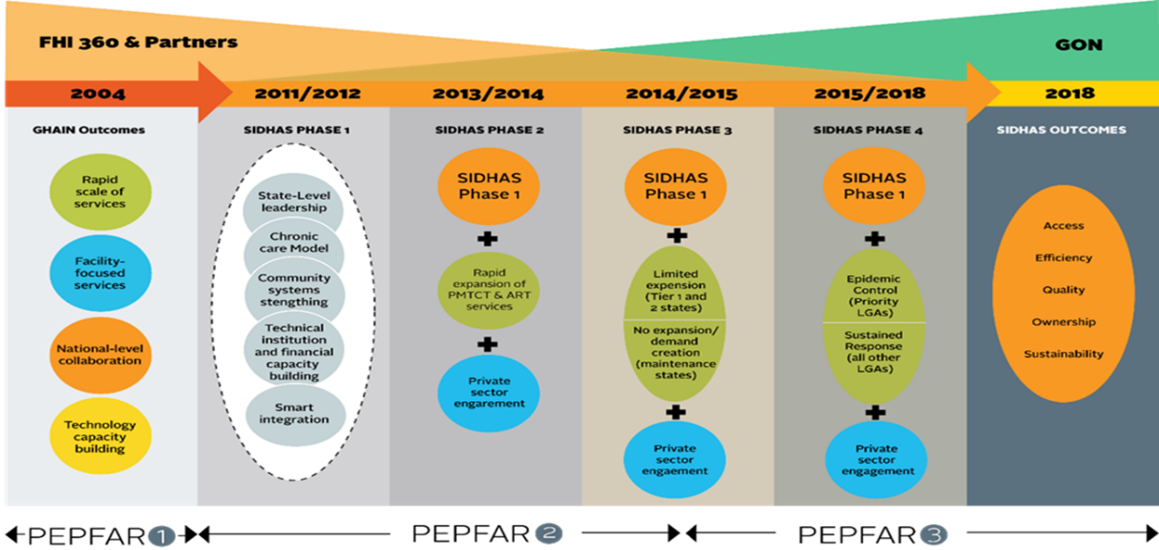

*Figure 3. SIDHAS Coverage in Nigeria*

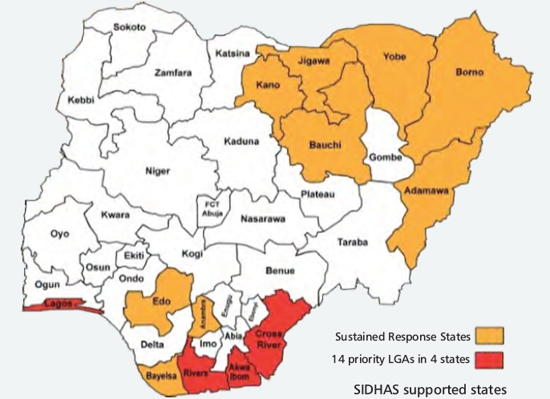

*Figure 4. Implementation Strategies for SIDHAS*

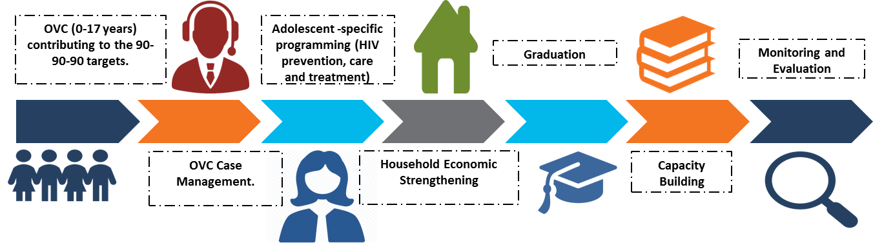

FHI 360 is currently implementing SIDHAS in collaboration with five primary partners: Achieving Health Nigeria Initiative (integrated services); Association for Reproductive and Family Health (ARFH) (community-based services); Deloitte Consulting, LLP (organizational development); German Leprosy and Tuberculosis Relief Association (TB and HIV integration); and Howard University Pharmacists and Continuing Education Center (pharmacy services). Past partnerships included the Axios Foundation, (logistics and supply chain management), Population Council (community operations research for Prevention of Mother to Child Transmission [PMTCT]) and University of Nigeria (health economics operations research). In addition, the activity previously engaged two subcontractors, Hygeia Foundation and Health Systems Consult Limited, to support private-sector engagement in two states.

The goal of the OVC component of SIDHAS is to assist the Government of Nigeria (GoN) in reducing the burden of HIV/AIDS amongst OVC aged 0-17 years who are infected, affected and/or living in high HIV prevalent areas. It is being implemented in 127 LGAs in 13 states. Achievements include:

(a) 90,334 households and 211,586 OVC ever enrolled; and

(b) 40,887 households and 91,286 OVC currently enrolled.

# METHODOLOGY

The DQA methodology included the following steps:

1. Desk review of activity documents, materials, and data, including:

* The organization’s SOP, guidelines, PIRS for the indicator, and other guidance documents for organizational M&E management, data management, and processing;
* Six months (October 1, 2017 to March 31, 2018) of SIDHAS OVC performance data for the PEPFAR indicators “OVC_SERV” and “OVC_HIVSTAT” as calculated using data elements within the NOMIS;
* State-level summary reports for the reporting period defined above; and
* Entries of beneficiaries and their households in NOMIS.

2. Key informant interviews (KIIs) and focus group discussions (FGDs) with members of the SIDHAS OVC M&E team at all levels. Since only one M&E focal person or staff was usually available in the field, the majority of the M&E systems assessments were conducted as KIIs.

3. Trace and verification of reported data with cross-checks across systems and records, including review of beneficiary folders and service forms.

4. Review and application of the five data quality standards (validity, reliability, integrity, precision and timeliness).

## SAMPLING METHODOLOGY FOR SITE SELECTION

A purposive sampling technique was used for the selection of DQA sites. This was based on USAID/Nigeria’s guidance and also based on the fact that DQAs for six OVC IMs were concurrently implemented during the period of the exercise: SIDHAS, LOPIN 2 (Local OVC Partners in Nigeria 2), STEER (Systems Transformed for Empowered Action and Enabling Responses), SMILE (Sustainable Mechanism for Improving Livelihoods and Household Empowerment), LOPIN 3 (Local OVC Partners in Nigeria 3) and LOPIN 1 (Local OVC Partners in Nigeria 1). All together, these six IM implement OVC activities in 22 Nigerian states, across 235 LGAs.

The selection criteria used are detailed below:

### INCLUSION CRITERIA:

* LGAs where USAID-supported OVC activities are actively being implemented by SIDHAS;
* LGAs which reported results for the OVC_SERV and OVC_HIVSTAT indicators for FY 2018 SAPR (October 1, 2017-March 31, 2018); and
* LGAs visited or within close proximity to those visited during the USAID/Nigeria FY 2017 DQA exercise for the OVC_SERV indicator for the STEER, SMILE and LOPIN 3 IMs.

### EXCLUSION CRITERIA:

* Sites located in high security level states, ranked at level four or for which access to the state requires passage through a level four state; and
* Sites located in a difficult, hard to reach terrain.

## SAMPLE SIZE

The IP’s central office, four IP state offices (Akwa Ibom, Anambra, Lagos and Rivers) and eleven CBOs (service delivery sites) were selected based on the criteria outlined above and visited for the DQA exercise. Table 3 below provides the complete list of sites selected and visited for the DQA exercise.

Table 3. List of Central, State, and CBO Offices/Sites Visited for the SIDHAS OVC DQA

|  |  |  |  |  |
| --- | --- | --- | --- | --- |
| S NO | TYPE OF LEVEL | NAME OF LEVEL | STATE/LGA | DATE OF VISIT |
| 1 | Central M&E Unit | Family Health International 360 (FHI 360) HQ office | Abuja | 6 June, 2018 |
| 2 | Aggregation level | SIDHAS state office | Anambra | 26 June, 2018 |
| 3 | Aggregation level | SIDHAS state office | Akwa Ibom | 28 June, 2018 |
| 4 | Aggregation level | SIDHAS state office | Lagos | 13 June, 2018 |
| 5 | Aggregation level | SIDHAS state office | Rivers | 25 June, 2018 |
| 6 | Service Delivery level | GLAD Foundation | Anambra/Anambra East | 25 June, 2018 |
| 7 | Service Delivery level | GLAD Foundation | Anambra/ Ayamelum | 25 June, 2018 |
| 8 | Service Delivery level | Women Community Livelihood Foundation (WOCLIF), | Akwa Ibom/Etinan | 28 June, 2018 |
| 9 | Service Delivery level | Women Community Livelihood Foundation (WOCLIF | Akwa Ibom/Uyo | 28 June, 2018 |
| 10 | Service Delivery level | Support Health Redemption Organization (SHERO) | Akwa Ibom/ Ikot Ekpene | 29 June, 2018 |
| 11 | Service Delivery level | Blissful Life for Youth Society of Nigeria (BLYSN) | Lagos/Kosofe | 13 June, 2018 |
| 12 | Service Delivery level | JAKIN NGO | Lagos/Ajeromi Ifelodun | 14 June, 2018 |
| 13 | Service Delivery level | Humanity Family Foundation for Peace and Development (HFFPD) | Lagos/Agege | 13 June, 2018 |
| 14 | Service Delivery level | Support for Mankind Development Initiative (SMDI) | Rivers/Ikot Ekpene | 25 June, 2018 |
| 15 | Service Delivery level | Youth Pro_File, (YPF) | Rivers/ Obio Akpo | 26 June, 2018 |
| 16 | Service Delivery level | Youth Pro_File (YPF) | Rivers/ Eleme | 26 June, 2018 |

Staff with OVC M&E responsibilities were interviewed for the M&E systems assessment across the three levels. A complete list of a personnel interviewed at various levels is provided in Annex section 8.8, Table 18. From the perspective of DQA coverage for data verification, a major strength was that 100% of aggregate data records were reviewed at the central, state, and CBO levels (Table 4).

Table 4. Data Coverage for SIDHAS OVC DQA, by Level

|  |  |  |
| --- | --- | --- |
| Data Coverage for SIDHAS OVC DQA, by Level | | |
| Level / Location | **Data Format(s)** | **Sample Covered for Data Verification** |
| Central M&E unit | Electronic (NOMIS) | All records / 100% |
| Four IP state offices (Akwa Ibom, Anambra, Lagos and Rivers) | Electronic (NOMIS) | All records / 100% |
| Service delivery level / CBO | Electronic (NOMIS) | All records / 100% |
| Service delivery level (cross-checks on source documents) | Electronic (NOMIS) and paper (beneficiary forms and folders) | 20 per CBO:  10 forward cross-checks – folder/form to the NOMIS, and  10 reverse cross-checks – the NOMIS to folder/form.  The average number of eligible forms reviewed per folder was about 5. |

## SELECTION OF BENEFICIARY FOLDERS AND FORMS FOR OVC INDICATOR REVIEW AT SITES

To ensure adequate time for the DQA team to complete all aspects of the DQA—including the M&E systems assessment, review of the data quality standards, data verifications, and cross-checks—the DQA team reviewed at least ten beneficiary folders (randomly selected, where feasible) for the service period between October 1, 2017 to March 31, 2018. All of the beneficiaries in each of the ten service folders which are less than 18 years of age were selected for cross-checks between the beneficiary service forms and the NOMIS. It must be noted that an OVC beneficiary household folder often contains more than one beneficiary service form. A beneficiary can be served multiple times in a span of six months, and there may be more than one eligible beneficiary per household. An additional ten unique beneficiary records from the NOMIS were traced back to the beneficiary folders for further cross-verification.

Indicator 1: all the beneficiaries (OVC and family members) in each beneficiary folder are selected for the cross-checks between beneficiary forms and the NOMIS.

Indicator 2: all the beneficiaries in each beneficiary folder that are less than 18 years are selected for cross-checks between the beneficiary forms and the NOMIS.

Details of the methodology for sampling (including random selection) and cross-checks are provided in Section 3.4.4 and Annex section 8.5 (Figure 15).

## DATA COLLECTION FOR VALIDATION OF THE SELECTED INDICATORS

Three processes were utilized to collect data for validation of the OVC_SERV and OVC_HIVSTAT indicators reported by SIDHAS. They include:

1. An M&E systems assessment, administered at each level of the data collection and reporting system, i.e., central M&E unit, state level, and CBOs (service delivery level);
2. Verification of reported data for the OVC_SERV and OVC_HIVSTAT indicators; and
3. Review of the five data quality standards (validity, reliability, integrity, precision and timeliness).

### M&E SYSTEMS ASSESSMENT

The M&E systems assessment evaluated the data management and reporting system, including off-site review of documents provided by SIDHAS, and on-site follow-up assessment at the SIDHAS central M&E unit, four state IP offices and selected CBOs.

### DATA VERIFICATION

At the central IP level, the DQA team reviewed documents for availability, timeliness, and the completeness of expected reports from the aggregate levels/IP state offices for the selected reporting period.

At the intermediate/IP state offices, the DQA team carried out the following steps to verify the data:

1. Document review: The DQA team reviewed availability, timeliness, and completeness of expected reports from service delivery sites for the selected reporting period.
2. Verifying reported numbers: To verify reported numbers, the DQA team:
   1. Re-aggregated the numbers submitted by the service delivery sites;
   2. Compared the verified counts to the numbers submitted to the next level (central IP M&E unit); and
   3. Identified reasons for any differences.

The data verification at the service delivery level/CBO sites involved the following processes:

1. Observation and description: This process involved the DQA team’s observation and description of the connection between the delivery of OVC services and the completion of the source document (beneficiary form) to record the HIV status of beneficiaries.
2. Review of source documents: The DQA team reviewed the availability and completeness of the OVC_SERV and OVC_HIVSTAT indicator source documents. At least 20 beneficiary records (randomly selected where feasible) for the selected reporting period were reviewed for the record of their HIV status.
3. Recounting reported results: This involved:
4. Reported numbers of OVC served and OVC less than age 18 with their HIV status reported to SIDHAS were recounted from available source documents (beneficiary forms);
5. The above numbers were compared and verified with the figures for OVC served and OVC less than age 18 with reported HIV status from the NOMIS for the period of review (October 1, 2017 to March 31, 2018); and
6. Reasons for any differences were identified and probed to determine if the differences were related to or impacted data quality standards.
7. Cross-checks were performed from beneficiary forms to the corresponding NOMIS entries, and vice versa. Spot checks were not carried out to verify the actual delivery of OVC services to the target population in order to protect beneficiary confidentiality.

During the data verification, SIDHAS-reported results on the NOMIS for OVC_SERV and OVC_HIVSTAT indicators for each CBO from October 1, 2017 to March 31, 2018 were captured using a Microsoft Excel template. At each CBO, DQA assessors reviewed relevant registers, folders and summary forms to verify the quality of data and to generate actual achievement for the indicator.

### DEFINITION AND INTERPRETATION OF THE VERIFICATION FACTOR

#### Definition of THE Verification Factor

For a specific site, the verification factor is the ratio of verified count (recounted by the DQA team from source documents) to the reported count (from the summary report prepared by the site) for a specific reporting period. It is usually expressed as a percentage. Mathematically, it can be expressed as:

Verification Factor = (Verified count at selected site / Reported count at selected site) x 100

#### INTERPRETATION OF THE Verification Factor

Verification factors greater than 100 percent indicate underreporting (i.e., the source documents show a higher actual count than the numbers reported in the site summary), while verification factors less than 100 percent indicate over reporting (i.e., the source documents show a lower actual count than the numbers reported in the summary). Both of these scenarios indicate a validity issue for data quality. A variance of less than ten percent in either direction is usually considered a minor issue. However, from the donor/funding perspective, underreporting leads to underestimation of the impact of the activity, while systematically high levels of over reporting not due to errors can lead to questions about the accuracy of the data reporting system.

### METHODOLOGY FOR CROSS-CHECKS AT THE CBO LEVEL

Cross-checks were performed between beneficiary folders and the NOMIS in two directions:

Cross-check A: From beneficiary folders and corresponding beneficiary service forms to the NOMIS; and

Cross-check B: From the NOMIS to beneficiary folders and corresponding beneficiary service forms.

The DQA team sampled beneficiary folders (randomly selected where feasible) to ensure adequate representation of the complete data available, with a minimum of ten folders selected, and adifferent set of beneficiary folders for each direction of cross-checks. Depending on the total number of folders at the CBO, at a minimum every **n**th folder was selected (where n=total number of folders divided by ten). The details of the cross-check methodology are provided below.

#### Cross-check A: From beneficiary folders (and beneficiary service forms) to NOMIS

* Using the selection methodology described above, the DQA team selected at least ten beneficiary folders containing five or more corresponding beneficiary service forms with unique identifiers and enrollment numbers for an OVC service provided in the reporting period.
* The team confirmed that each of the five or more service forms were complete in the ten folders, indicating HIV status of the OVC served in the reporting period and the OVC service provided**.** If any of the forms were incomplete, the relevant details were noted.
* Using the identifying enrollment number/unique identifier on the service form, the beneficiary was traced in the NOMIS to confirm if the corresponding entry existed, and if the basic details (ID, age, sex, etc.) were correct.

#### Cross-check B: From NOMIS to beneficiary service form

* Using the sampling methodology described earlier (including random selection where feasible), the DQA team selected a different set of at least ten unique identifiers and enrollment numbers for OVC less than age 18 served in the NOMIS for the reporting period.
* Using the identifying enrollment number/unique identifier in the NOMIS, the team traced and verified the beneficiary on the service form in the corresponding folder to confirm if the details were correct. The enrollment forms were also reviewed for completeness.

A diagrammatic depiction of cross-checks is provided in Annex section 8.5 (Figure 15).

## DQA TOOL

The MEASURE Evaluation multi-indicator routine DQA tool (2015)[3] guided the M&E system assessment and data verification processes. The DQA team utilized the multi-indicator tool to measure the following:

1. Strength of the data management and reporting system, for the indicators based on a review of the activity’s data collection and reporting system, including responses to questions on how well the system is designed and implemented.
2. Accuracy of reported data through the calculation of verification factors (i.e., the ratio of the recounted value of the indicators to the reported value) for the two indicators, from October 1, 2017 to March 31, 2018, based on data verification performed at each level of the reporting system. This included:
   1. Number of OVC served and OVC less than age 18 with HIV status reported at CBO level accurately reported in the NOMIS;
   2. Cross-checks: Number of OVC served and OVC less than age 18 with HIV status validated from source documents (i.e., enrollment forms, service form and follow up form);
   3. Percentage of data reports from all participating CBOs in a state accurately reported at the state level; and
   4. Percentage of data reports from all participating SIDHAS states in Nigeria accurately reported at the central level.
3. Availability, completeness, and timeliness of reports through percentages calculated at the CBO, the state, and the central M&E Unit.

The DQA team used the ADS 201 USAID recommended DQA checklist[4] to review of the five data quality standards - validity, reliability, timeliness, precision and integrity. Information needed to complete the USAID DQA checklist were already contained in the RDQA tool but the DQA team also probed for more information of areas that were not adequately covered by the RDQA tool.

## OTHER OPERATIONAL CONSIDERATIONS FOR DQAS

In conducting DQAs, the focus is on the indicator, not on the IP or the IM. For this DQA exercise, the DQA team assessed the OVC_SERV and OVC_HIVSTAT indicators as a whole, including all component parts, among the various partners who collect data for the indicators. The numerator disaggregates of the OVC_HIVSTAT indicator were also assessed. The level of consistency —whether different IPs collect and report the same indicator data when compared to one another—is a key finding.

During desk review and training, the DQA team examined the PEPFAR MER 2.0 indicator reference guide which contains the PIRS for the indicators. The team also reviewed key aspects about indicator data quality before site visits. When the DQA team met with the SIDHAS team, the DQA team assessed the PIRS for both indicators contained in the SIDHAS Activity Monitoring, Evaluation and Leaning Plan (AMELP). The DQA team obtained information from the SIDHAS team regarding their definition of the indicators, methodology used to collect data for the indicators, and other questions to confirm if the team at SIDHAS understood the indicators as USAID intended it to be understood. The DQA team also asked the SIDHAS team whether they had a PIRS for the indicators and compared it to the USAID Mission’s “master” PIRS (PEPFAR MER 2.0 indicator reference guide). This was to ensure a match, and to determine if customizations might affect the data, or were just specifications to add clarity and detail pertaining to SIDHAS and did not alter the consistency of the data. Documentation in the PIRS includes any limitations to the data, a determination of whether the data are deemed to be of sufficient quality to be reported externally, any migration or other plans of action needed (including more frequent DQAs), as well as the expected date of the next DQA.

During the field work, in order to allay initial apprehensions of the IP and their staff, the DQA team emphasized to the IP that a Data Quality Assessment differs from a Data Quality Audit, although both are abbreviated in the same manner (through the acronym DQA). The team also highlighted the intention to use the DQA results as a ‘learning tool’ for USAID and the IP to work together to resolve any data quality issues or limitations that are uncovered during the exercise.

When the site visits and the analysis are aggregated and completed, the DQA team can report on indicator strengths and areas that require improvement. In addition to determining whether the system as a whole is producing accurate data, the team can also comment on whether the indicator is yielding the expected data, and what limitations USAID should recognize when using or reporting on the indicator. Importantly, after field-based work, the DQA team debriefs the IP regarding any inconsistencies. Depending on the inconsistencies and/or areas for improvement, the team provided feedback and solutions, mitigating actions, and, as appropriate, solicitation of suggestions from the IP and USAID.

## DATA ANALYSIS

Data were entered, processed, and analyzed using the MEASURE Evaluation tool and Microsoft Excel. Information were presented using charts, maps, tables, and spider graphs (cobweb). Descriptive statistics such as range, frequencies, mean, and percentages were used to describe and summarize DQA data verification findings. Since purposive sampling was used for site selection, statistical summaries were presented only in the context of the sampled beneficiaries and may not be fully representative of the beneficiary population. The selected MER indicators, OVC_SERV and OVC_HIVSTAT, were scored and measured using all of the available numbers reported for the indicators, to determine if CBO data was valid as reported in NOMIS. Qualitative reasons for discordance between CBO data and NOMIS (over-reporting/under-reporting) or concordance (validated) as reported in NOMIS were summarized. As per the guidelines incorporated in the Measure RDQA tool, verification factors of +/- ten percent were considered to be marginal when reporting on the validity of IP reported data.

# FINDINGS

## M&E SYSTEMS ASSESSMENT – SIX FUNCTIONAL AREAS

### SIDHAS CENTRAL M&E UNIT

#### M&E STRUCTURE, FUNCTIONS, AND CAPABILITIES

The M&E unit has an organogram which identifies positions with data management responsibilities and functions of the M&E team. All new M&E staff receive comprehensive training and orientation in data reporting. The DQA team sighted a spreadsheet containing a comprehensive training plan. A data flow chart showing the staff responsible for reviewing reports at each level prior to submission was clearly visible in the M&E Standard Operating Procedure (SOP). Designated staff responsible for reviewing data quality were also clearly outlined in the SOP. Feedback on reports is provided monthly to states IP offices, and supportive supervisory visits are carried out to lower reporting levels on a quarterly basis. During the visits, the central M&E staff make attempts to visit pre-selected CBOs and VCs.

#### INDICATOR DEFINITION AND REPORTING GUIDELINES

The central M&E unit disseminated the PIRS and an indicator dictionary containing all indicators, including OVC_SERV and OVC_HIVSTAT with the sub-national units. These are also contained in the SIDHAS Performance Monitoring Plan (PMP). Embedded in the indicator dictionary, is the description of services for each indicator, along with the source documents, reporting time and procedure for reporting on each indicator. The DQA team also sighted delivery notes showing the confirmation of receipts from state offices for the reporting guidelines / SOPs.

#### DATA COLLECTION AND REPORTING FORMS AND TOOLS

SIDHAS uses the standard national tools for reporting on the OVC indicators. All states, CBOs and facilities use the same tools for reporting. The instructions on how to fill these tools are provided within the first few pages of the tools, and all reporting units are advised to always read the instructions before completing the forms. Regarding data aggregation, analysis and manipulation, the SOP provides a clear description of the steps involved. Data collected has sufficient precision to measure the indicator (e.g. age, sex etc.). In the past, addendum forms were created to support the national tools where necessary. However, the present national tools in use are precise enough to measure the necessary components of both indicators.

#### DATA MANAGEMENT PROCESSES

The NOMIS has automated data validation functions e.g. it flags double data entries. Data goes through quality checks by designated M&E staff before reaching the Director, Monitoring and Evaluation (DME), who finally verifies the data before reporting to USAID/Nigeria. A written data back-up procedure is embedded in the Data Management SOP. Data backups are done monthly at the central level, on a number of different platforms including a central database, cloud-based backup and external hard drive. A written procedure to address late, incomplete, inaccurate and missing reports is contained in the SOP.

The central M&E unit also has documentation containing the steps taken to resolve data inconsistencies. At the central level, data collated are analyzed for inconsistencies and errors. Feedback is provided to the states for clarifications and resolution before data are reported back to the central office, alongside justification to support any updates in the data. The DQA team sighted previous trip reports of supervisory site visits made by the central M&E unit to the states. A copy of the written policy containing the period of storage of source documents was also sighted. The Data Management SOP contains details of how source documents should be archived.

#### LINKS WITH THE NATIONAL REPORTING SYSTEM

Standard national tools are used for data collection and reporting. Although the NOMIS is a single channel of reporting, data are reported from the IP state offices to both the state Ministries of Women Affairs and Social Development (MWASD) and to the IP central office, from where it is reported to USAID/Nigeria. Figure 5 shows the spider chart of the SIDHAS OVC M&E system assessment with deficits in the links with the national reporting system because of parallel reporting channels i.e., to government and USAID/Nigeria. However, there are mechanisms in place to harmonize reported data to both reporting entities such as the OVC program TWG meetings with OVC program IPs and the Federal Government (FG), during which attempts are made to harmonize OVC program data across board to avoid double-counting of OVC beneficiaries.

#### Use of Data for decision making

The central M&E unit prepares charts from analyzed data, used during data review meetings and for dissemination to key stakeholders. The DQA team sighted evidence of analyzed data discussed at previous data review meetings. These charts are developed and presented by the Technical Officer M&E at the central level. The central M&E unit also provides guidance to sub-reporting levels on data use, as evidenced by templates shared with the state offices for presentations at data review meetings.

*Figure 5. Spider Graph of M&E Systems Assessment - SIDHAS Central M&E Unit*

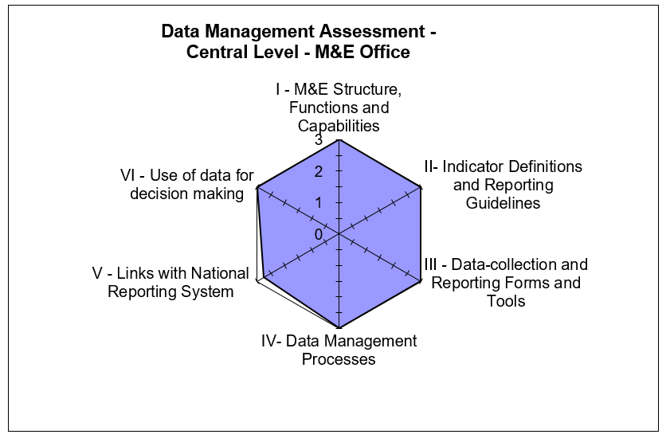

#### STRENGTHS – SIDHAS CENTRAL M&E UNIT

* Responsibility for data review at the central level has been assigned to specific members of the M&E team.
* The SOP on data management includes clear steps for data aggregation, quality checks, and feedback to states on observed data discrepancies.
* SIDHAS uses the national OVC reporting tools and also has in-house information technology capacity for NOMIS.

#### AREA FOR IMRPOVEMENT - SIDHAS CENTRAL M&E UNIT

* None.

#### RECOMMEDATIONS - SIDHAS CENTRAL M&E UNIT

* None.

### SIDHAS STATE M&E UNIT

#### M&E STRUCTURE, FUNCTIONS, AND CAPABILITIES

The SIDHAS state offices have designated M&E staff which include the Senior Technical Officer (STO) M&E, Technical Officer (TO) M&E and Assistant Technical Officer (ATO) M&E as sighted in the SIDHAS staff office organogram sighted in the Anambra state office. The M&E staff have received relevant training to carry out their assigned responsibilities which include training on revised national tools, refresher training on NOMIS and basic concept of M&E. Training certificates were sighted at the SIDHAS Lagos state office.

The M&E team at the SIDHAS state offices review the quality of data received from the CBOs prior to submission to the central level. The STO M&E at the state office reviews collated reports and shares with the Senior Program Officer (SPO) and Senior Program Manager (SPM) for additional review before submission is made to the SIDHAS central office. When the STO M&E is not available, the TO M&E and ATO M&E fills in the position. Feedback on the quality of reports received at the state offices are provided to CBOs via e-mails, phone calls and during supervisory visits. The state offices also receive feedback on reports submitted to the SIDHAS central office mostly via emails and during supervisory visits. Evidence of supportive supervisory visits to CBOs was sighted at the Akwa Ibom and Lagos state offices contained in completed Continuous Quality Improvement/Technical Assistance (CQI/TA) forms.

#### INDICATOR DEFINITION AND REPORTING GUIDELINES

The four SIDHAS state offices make use of the PEPFAR MER indicator guide (PIRS) which defines the indicators and the methods of calculation. In addition, the M&E activities of the state offices are guided by the SIDHAS “SOP for Routine Data Collection and Management” which includes details on the reporting requirements and timelines. In Akwa Ibom state, the DQA team sighted different SOP documents that address specific thematic areas which makes it easy for reference purpose when compared with a single SOP that captures information across multiple areas.

#### DATA-COLLECTION AND REPORTING FORMS AND TOOLS

The states aggregate data using NOMIS export files received from CBOs. The states also ensure the availability and consistent use of the national OVC tools by CBOs. The tools for reporting on the two indicators were sighted during the DQA exercise. They include the household vulnerability assessment form, vulnerable children enrollment register, vulnerable children service form, caregiver/household head service form, referral form for vulnerable household, vulnerable children follow up child status index (CSI) form and HIV test results and graduation care plan completion checklist. Clear instructions on how to complete the reporting tools are contained inside the tools. The OVC NOMIS user guide provides guidance on data entry into the NOMIS. As at the time of the DQA exercise, there was no stock out of reporting tools.

#### DATA MANAGEMENT PROCESSES

The NOMIS database has a number of inbuilt data validation mechanisms that do not allow multiple enrollments on the database, enrollment of children older than 18 years as an OVC and children less than 15 years as a caregiver. The state M&E teams conduct regular data verification checks (gaps and outliers) on CBO data before submission to the central office.

All four states back up data using hard drives. In addition, SIDHAS Anambra state backs up data using the shared drive, W-Drive and e-mails, Lagos State uses the e-mail, Akwa Ibom uses the FHI 360 server and Rivers also backs up on the computer system. Three states (Akwa Ibom, Lagos and Rivers) back-up data monthly while Anambra state backs up data on a weekly basis. The SIDHAS SOP for data management which contains written procedures on how to address late, incomplete, inaccurate and missing reports was sighted at the states visited. The four states use the change management form and issues log book to document data discrepancies and how the issues were resolved. The states visited are aware of the storage period of source documents, contained in the OVC Case Management SOP and OVC case closure checklist. The SOP also contains how source documents should be archived. The DQA team sighted trip reports of supervisory visits conducted by the state IP officers to the CBOs.

In Akwa Ibom state, the DQA team sighted a change management register used in documenting and tracking inconsistency and discrepancies in data. The state also uses an “Issues Log Book” which is filled during data review meetings. The log book documents gaps in reported data, the actions to be taken to address the gaps identified and the timeline for implementing the action points.

#### LINKS WITH THE NATIONAL REPORTING SYSTEM

Standard national tools are used for data collection and reporting. Although the NOMIS is a single channel of reporting, data sharing occurs horizontally from the IP state office to the State MWASD. The system records information about where the service is delivered as per standard national conventions including naming conventions (e.g. state code, LGA code, CBO code, household number and OVC unique number).

#### use of data for decision making

Capacity of the state M&E staff have been built to analyze data, create charts and fact sheets which are disseminated to various stakeholders during data review meetings. Issues regarding limitations that may exist in data are also shared with the central IP office and with stakeholders following data analysis. Data analysis by the SIDHAS Akwa Ibom state office has informed the provision of HIV testing services to OVC with unknown status and has also informed linking of OVC program beneficiaries, enrolled into care, to ART service provision.

Figure 6, Figure 7, Figure 8 and Figure 9 show the spider graphs that display the M&E systems assessment for Anambra, Akwa Ibom, Lagos and Rivers states respectively. Across the four states, it can be observed that the area on links with the national reporting system shows some gaps which is as a result of parallel reporting channels i.e., to government and donor agencies. Another area that requires improvement for Akwa Ibom state is in the use of data for decision making. The DQA team made a recommendation to the state M&E team to develop more charts using OVC indicator data.

*Figure 6. Spider Graph of SIDHAS OVC M&E Systems Assessment: Anambra State*

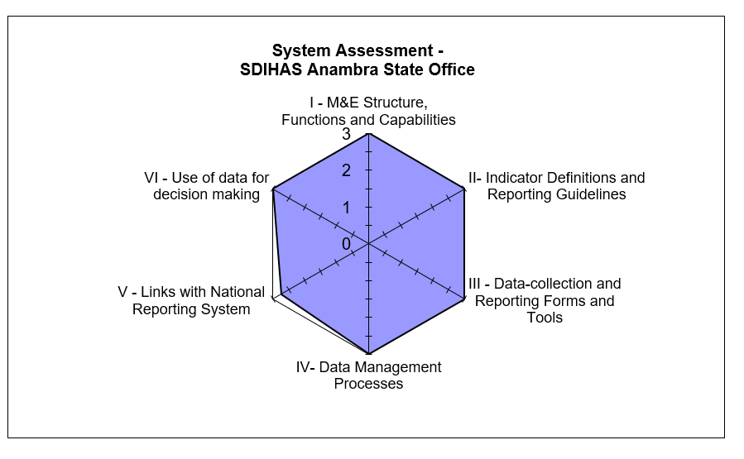

Figure 7: Spider Graph of SIDHAS OVC M&E Systems Assessment: Akwa Ibom State

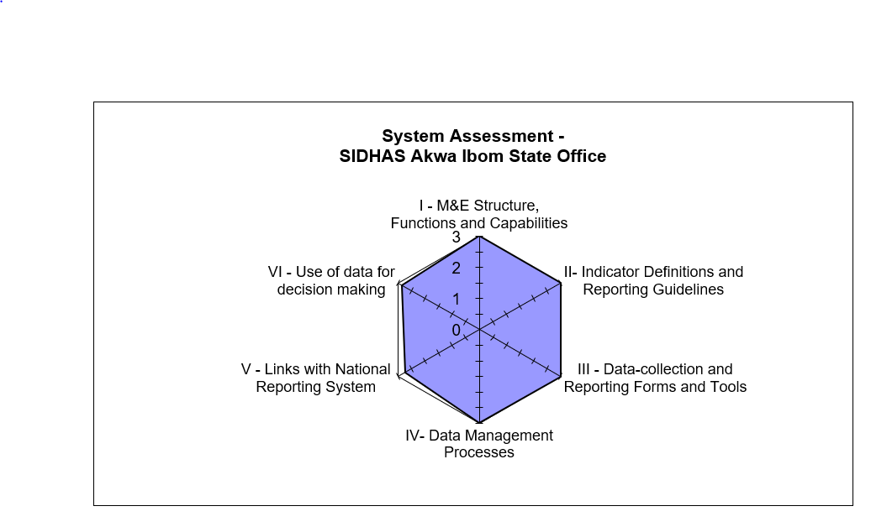

*Figure 8. Spider Graph of SIDHAS OVC M&E Systems Assessment: Lagos State*

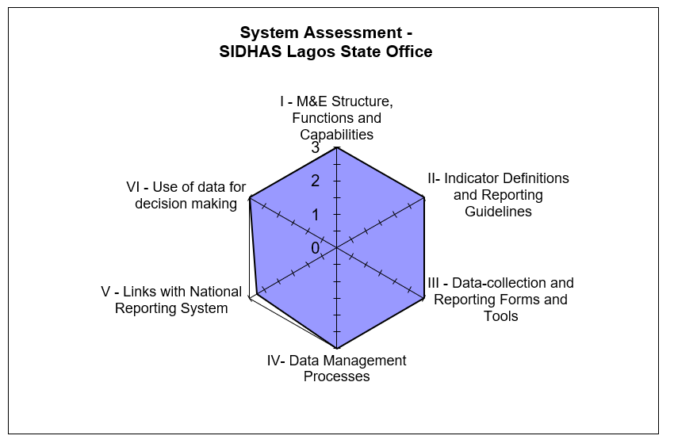

Figure 9: Spider Graph of SIDHAS OVC M&E Systems Assessment: Rivers State

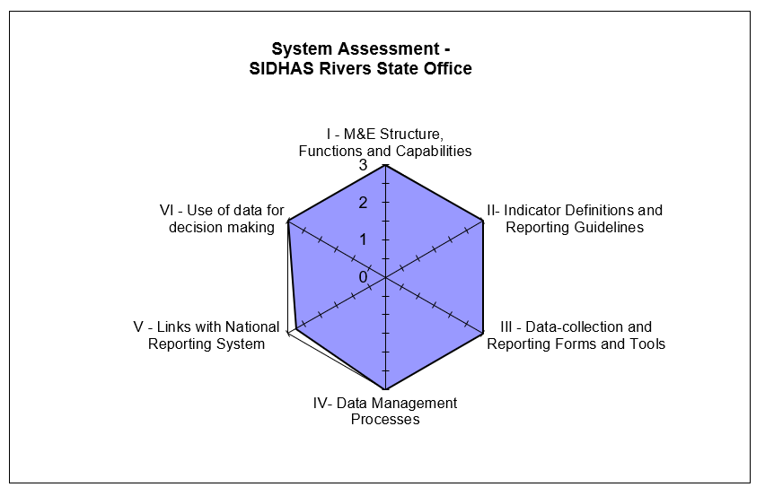

#### STRENGTHS – SIDHAS STATE LEVEL

* All M&E staff at the state level have received relevant training to carry out their assigned responsibilities.
* All state offices have and use the SIDHAS SOP for data management, PIRS for the indicators being assessed, and are using the NOMIS database for reporting.
* State offices utilize multiple backup processes e.g. hard drive and cloud.
* Data are collated and presented in charts, tables etc. and disseminated to various stakeholders for decision making in all the four states.

#### AREAS FOR IMPROVEMENT – SIDHAS STATE LEVEL

* Few charts developed using OVC indicator data at the Akwa Ibom state office.

#### RECOMMEDATIONS – SIDHAS STATE LEVEL

* Develop and disseminate more findings from analyzed data to key stakeholders using OVC indicator data (in Akwa Ibom state).

### SIDHAS SERVICE DELIVERY LEVEL (CBOS)

A comparative M&E systems assessment of the eleven CBOs visited by the DQA team is presented below in narrative and tabular form, with details of the specific functional areas.

#### M&E STRUCTURE, FUNCTIONS, AND CAPABILITIES

In all SIDHAS CBOs visited by the DQA team, it was observed that Community Volunteers (CVs) enter beneficiaries’ information into the service delivery form. The forms are submitted to Data Entry Clerks (DECs) who review the data before entering the information into the registers and into the NOMIS. After data has been entered into the NOMIS, spot checks are carried out by the M&E officers. Different CBOs utilize different methods for data review, some review the data as a team before sending to the next level (BLYSN, JAKIN, HFFPD, SMDI and YPF) while at SHERO CBO, reports are collated and reviewed by the M&E Officer, who sends it to the CEO for review, after which its forwarded to the CBO Project Management Team (PMT) for review before submission is made to the next level. CBOs receive regular feedback on data reported to the SIDHAS state M&E team via e-mails and CQI/TA forms. In addition, CBOs receive supportive supervisory visits from SIDHAS state offices, reports of such visits were sighted by the DQA team.

All relevant staff within all the CBOs visited have received M&E training. The last M&E training received was in March 2018 on the revised OVC national tools. Training reports and certificates were sighted in five of the CBOs visited, WOCLIF (Etinan and Uyo), BLYSN, YPF (Obio Akpo and Eleme). In the absence of the focal M&E Officer, a staff of the CBO, trained in M&E (other M&E Officers or the M&E Assistant) performs the role of the M&E Officer to ensure there are no gaps in data reporting.

#### INDICATOR DEFINITION AND REPORTING GUIDELINES

All CBOs visited have and use the PEPFAR Nigeria FY 18 OVC indicator guide and MER indicator guide (PIRS) which defines the two indicators and the methods of calculation. In addition, the SIDHAS SOP for Routine Data Collection and Management was also sighted and in use at all CBOs visited. In one CBO (Youth Pro_File), the guideline for indicator data entry into the NOMIS was pasted on the wall.

#### DATA-COLLECTION AND REPORTING FORMS AND TOOLS

Data collection tools and forms which include enrolment, OVC and caregiver service, risk assessment, HIV result, follow up and child care plan forms with clear instructions on use were available at all CBOs visited. National paper-based tools and the NOMIS database were consistently utilized during the period under review. Clear instructions on how to complete the tools were included in the SIDHAS SOP for routine data collection and management, NOMIS user guideline and on the data collection and reporting forms and tools which were sighted in the CBOs visited. All the CBOs had adequate supply of data collection tools.

All CBOs assessed in Akwa Ibom state were using old/obsolete Vulnerable Children (VC) service forms as seen during the cross checks despite the fact that the new service tools were rolled out in June 2017 and all CBOs had adequate stock of the revised form. The reason stated for non-usage of the revised form was to avoid wastage of the old reporting tools. At all the CBOs visited in Akwa Ibom state, numerous cancellations (on dates and services provided) were observed on the service forms using correction fluid.

#### DATA MANAGEMENT PROCESSES

Diverse methods were employed to ensure data quality and prevent double counting at the CBOs. In this regard, the findings at the CBOs assessed include:

1. Utilization of a built-in NOMIS function that identifies and removes duplicate values and disallows entries of children above 18 years as OVC (100 percent of CBOs);
2. The CBO M&E staff review data and conduct spot checks; and
3. The CBO M&E Officer signs and dates reports after reviews (SHERO).

CBOs utilized both local means and cloud technology to backup data periodically. Data was not backed up monthly as expected in SHERO CBO. Complete details on data backup methods for CBOs in Anambra, Akwa Ibom, Lagos and Rivers are provided in the Annex section 8.4 (Table 15)

In terms of maintaining confidentiality of beneficiary records, storage rooms and cabinets for beneficiary records were observed to be under lock and key. Staff and CVs in WOCLIF and SHERO CBOs were made to sign the confidentiality and non-disclosure forms to ensure confidentiality of beneficiary records. In two CBOs (HFFPD and SHERO), the arrangement of beneficiary folders in horizontal position made retrieval of folders for cross checks difficult. All CBOs are aware of the storage period of source documents before disposal.

#### LINKS WITH NATIONAL REPORTING SYSTEM

Standard national tools are used for data collection and reporting. The NOMIS system clearly records information about where the services are rendered, using standardized naming conventions (e.g., the state, LGA, ward) and the unique identification code. CBOs have links with the national reporting system through data reported to respective LGA OVC focal persons, State MWASD and Local Action Committee on AIDS (LACA) Managers. Data are also reported by the CBOs within the states to respective SIDHAS state offices.

#### USE OF DATA FOR DECISION MAKING

All the CBOs reported that the M&E Officer and the M&E team analyze data to develop charts, tables etc. for dissemination to various stakeholders. The CBOs had the developed charts displayed on their office walls. CBO staff receive technical assistance/ guidance on data use during review meetings and supervisory visits. CBOs disseminate findings from analyzed data and develop action plans for identified challenges at CBO and state data review meetings. Analyzed data are also shared with the state MWASD and key stakeholders in the community.

At two CBOs (Youth Pro_File [Obio Akpo and Eleme]), the results of analyzed data informed the employment of CVs resident within their community of assignment, to enable them work more effectively and follow up on OVC and members of their households. Also, at four CBOs (WOCLIF [Etinan and Uyo], SHERO, SMDI), results of analyzed data informed the prompt receipt of OVC birth certificates by liaising with the National Population Commission (NPC).

#### STRENGTHS – SIDHAS SERVICE DELIVERY LEVEL/CBO

* CBOs have trained M&E staff.
* Procedures are in place for data compilation and reporting when responsible staff are not available.
* The PIRS on the indicators, SOP for data management and national OVC reporting tools are available and in-use
* The NOMIS software was in use and password protected.
* Beneficiary folders are stored under lock and key with limited access.
* Data are backed up routinely using external drive and the cloud.
* Data are analyzed and used for decision making.

#### AREAS FOR IMPROVEMENT – SIDHAS SERVICE DELIVERY LEVEL/CBO

* Arrangement of beneficiary folders was in horizontal position instead of vertical position at HFFPD and SHERO CBOs, making retrieval difficult.
* Use of outdated VC service forms by CBOs in Akwa Ibom state.
* Numerous cancellations on service forms with correction fluid observed at CBOs in Akwa Ibom state.
* Inconsistent data back-up at SHERO CBO.

#### RECOMMENDATIONS - SIDHAS SERVICE DELIVERY LEVEL/CBO

* Provide capacity building for CBO staff on the proper arrangement of beneficiary folders for easy retrieval (HFFPD and SHERO CBOs).
* Discourage the use of outdated VC service forms and encourage the use of updated forms across all CBOs in Akwa Ibom state.
* Provide refresher training for CBO CVs in Akwa Ibom state on how to properly fill data collection tools.
* Encourage consistent monthly data back-up at SHERO CBO.

## DATA QUALITY STANDARDS

### VALIDITY

Validity is the extent to which a measurement is well-founded and corresponds accurately to the real world. It pertains to measuring what is intended to be measured. Details of the DQA team’s review of data quality in the context of the OVC indicators are provided below.

#### DATA COLLECTION

*Indicator 1- OVC_SERV:* The data are collected during provision of services and follow up visits by CVs to OVC and caregivers using the vulnerable children service form, caregiver/household head service form” and graduation forms/checklist/plans.

*Indicator 2-OVC_HIVSTAT:* The data, including HIV Status are collected at the point of registration into the OVC activity, during provision of service and follow up visits using the vulnerable children enrollment form, vulnerable children service form and vulnerable children follow up Child Status Index (CSI) form. In addition, other tools such as HIV test results, HIV risk assessment results and other confidential and case management and monitoring tools are used to document the HIV status of beneficiaries.

CVs enter services provided in the approved national tools, which are then collated and reviewed for accuracy and completeness by the CBO M&E Officer. The DEC enters the data into the NOMIS database. Quality checks of data entries in the NOMIS are conducted by the CBO M&E Officer.

#### DOES THE DATA COLLECTED MEASURE WHAT IT IS SUPPOSED TO MEASURE?

*Indicator 1: OVC_SERV:*

As part of the OVC indicator, the following data are collected:

* Total number of VC who are served (age 0-17) i.e. OVC that actually received services in the past three months;
* Total number of OVC caregivers (age 18 and above); and
* Total number of OVC that graduated.

The indicator matches the PIRS and is a direct measurement as per the standard indicator definition. This corresponds to what is needed or intended for an OVC IM collecting OVC_SERV data.

*Indicator 2: OVC_HIVSTAT:*

As part of the OVC indicator, the following data are collected:

* Total number of OVC less than 18 years with HIV status reported to IPs (including report of no status).

The OVC_HIVSTAT indicator matches the PIRS and is a direct measurement according to the standard indicator definition. The data collected by the IM measures the total number of OVC less than 18 years who reported their HIV status including report of no status to SIDHAS. Data for this indicator are also collected as disaggregates to make up the whole: ‘Reported HIV positive to IP,’ ‘Reported HIV negative to IP,’ and ‘No HIV status reported to the IP’.

#### UNDERSTANDING THE INDICATOR DEFINITION

The PIRS document for the two indicators was available at all the levels assessed. Staff are conversant with it at the central, state and CBO levels.

#### DATA REPORTING

*Indicator 1: OVC_SERV*

As shown in Figure 10, 100 percent of the OVC_SERV data reported by the four states to the central level were available, and matched the data reported to USAID/Nigeria. Data reported by the CBOs to the states were verified and found to be 100 percent accurate for the four states. With consideration of the +/- ten percent acceptable variance for determining the accuracy of verified data, 100 percent of reported CBO data verified were within the acceptable range. Overall average accuracy of verified data across all sites (central, states and CBOs) was 100 percent, hence, data reported data are considered suitable for decision making.

Figure 10. Data Verification by level of reporting of SIDHAS OVC sites: OVC_SERV

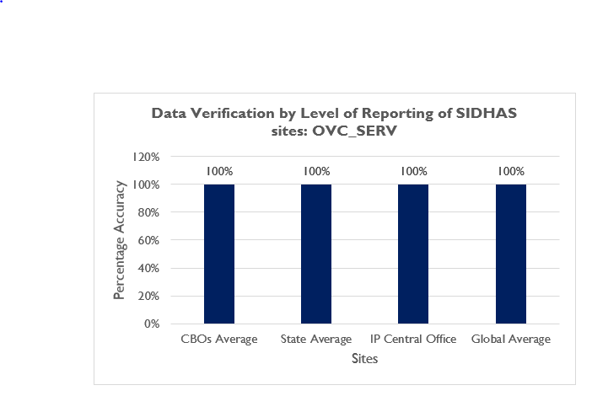

*Indicator 2: OVC_HIVSTAT*

A 100 percent of the total OVC_HIVSTAT numerator total and disaggregate data: ‘Reported HIV positive to the IP’, ‘Reported HIV negative to the IP’ and ‘No HIV status reported to the IP’; reported by the four states to the central level were available for assessment, and matched the data submitted to the USAID/Nigeria. Similarly, the total OVC_HIVSTAT numerator total and disaggregate data submitted by the CBOs to the states were verified and found to be 100 percent accurate for the four states (Figure 11). With consideration of the +/- ten percent acceptable variance for determining the accuracy of verified data, all CBO data verified were within the acceptable range. Overall average accuracy of verified data across all sites (central, state and CBO) was 100 percent, hence, reported data are considered suitable for decision making.

Figure 11: Data Verification by level of reporting of SIDHAS OVC sites: OVC_HIVSTAT

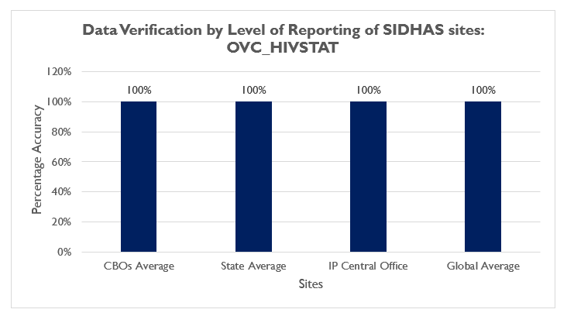

Figure 12 below shows the verification factors calculated for both the OVC_SERV and OVC_HIVSTAT indicators across the CBOs visited. The reaggregated data were 100 percent accurate at all the CBOs visited.

Figure 12. Data Verification factor by CBOs (OVC_SERV and OVC_HIVSTAT)

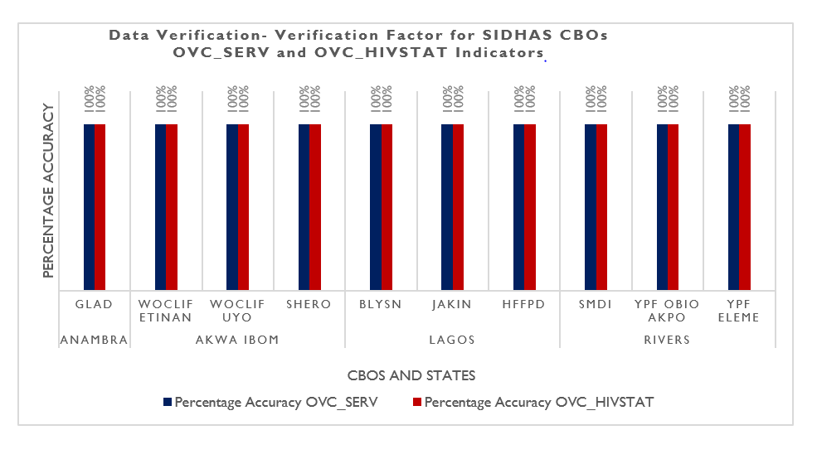

#### STRENGTHS

* Data for both indicators are collected as stipulated by the indicator reference guide using national approved tools.
* The “HIV status update form” on the NOMIS is used to input and update the HIV status of the beneficiaries for accurate reporting.

#### VALIDITIY ISSUES IDENTIFIED

Validity Issue 1: Errors noted during cross-checks from the source documents to the NOMIS and vice versa.

Indicator 1: OVC_SERV

Six CBOs had issues with proper documentation of data on the source documents. Five percent of beneficiaries’ forms reviewed during the cross checks had incomplete, missing or incorrect entries (Table 5). Some of the errors enumerated include:

* Services provided to some beneficiaries were indicated on the VC service forms but not indicated on the NOMIS database (GLAD, WOCLIF Etinan and Uyo, SHERO, BLYSON and JAKIN).
* Dates of service provision were missing on some VC service forms but available on the NOMIS (WOCLIF Etinan).
* Some beneficiary VC service forms had service provision dates different from the dates on the NOMIS e.g. some households enrolled into care in January 2018 as seen on the service forms had December 2017 as the date on the NOMIS (SHERO, BLYSON, WOCLIF Uyo and Etinan).
* Some beneficiaries marked “graduated” on the VC service form were still found to be “active” on the NOMIS database with documented services provided within the review period (WOCLIF Uyo and Etinan).
* Data entry omission – service forms were observed to have missing demographic records, household and OVC numbers.
* The team observed two NOMIS entries that are beneficiaries in the same household with same unique number and details (SHERO).
* Transcription error in the age of one beneficiary, recorded as minus seven (– 7) years old in the NOMIS and documented on the service form and enrollment form as 17 years old (HFFPD).

During the cross-checks from the source documents to the NOMIS, it was observed that five percent of the NOMIS entries were incomplete, missing or incorrect. These errors were due to an inability to carry out real time data entry into the NOMIS e.g. information sighted in the follow up assessment forms were not updated on the NOMIS database (SMDI).

Table 5. Cross Check Findings from SIDHAS CBOs in Anambra, Akwa Ibom, Lagos and Rivers States for OVC_SERV

|  |  |  |  |  |  |  |  |  |  |  |  |  |
| --- | --- | --- | --- | --- | --- | --- | --- | --- | --- | --- | --- | --- |
| Cross Check Findings - SIDHAS (OVC_SERV) | | | | | | | | | | | | |
| Cross Check Findings | **Lagos** | | | **Rivers** | | | **Akwa Ibom** | | | **Anambra** | **Total** | |
| **BLYSON** | **HFFPD** | **JAKIN** | **SMDI** | **YPF Obio_**  **Akpo** | **YPF Eleme** | **WOCLIF Etinan** | **WOCLIF Uyo** | **SHERO** | **GLAD Anambra East & Ayamelum** | **No.** | **%** | |
| Total cross checks: NOMIS to beneficiary folders and vice versa | 20 | 20 | 24 | 20 | 20 | 20 | 20 | 20 | 20 | 20 | 204 |  | |
| Total cross checks by beneficiary forms | 100 | 100 | 100 | 100 | 100 | 100 | 100 | 100 | 100 | 102 | 1002 |  | |
| Number of beneficiary forms with incomplete, missing or incorrect entries | 11 | 0 | 9 | 0 | 0 | 0 | 8 | 12 | 6 | 3 | 49 | 5% | |
| Number of NOMIS entries that are incomplete, missing or incorrect | 0 | 0 | 5 | 10 | 0 | 0 | 13 | 9 | 9 | 0 | 46 | 5% | |

Indicator 2: OVC_HIVSTAT

Six CBOs had issues with proper documentation of data on the beneficiaries’ forms. One percent of beneficiaries’ forms reviewed during the cross checks had incomplete, missing or incorrect entries (Table 6). In addition to the errors highlighted under indicator 1 above, the following errors were noted for the OVC_HIVSTAT indicator data:

* The HIV status of beneficiaries documented on the service form did not correspond with the HIV status inputted within the NOMIS database e.g. a beneficiary was noted to have a recorded HIV negative status on VC service form but a positive status on the NOMIS (WOCLIF Uyo and SHERO).
* The HIV status of beneficiaries was not indicated on some beneficiaries’ VC service forms and on the NOMIS (JAKIN).

During the cross-checks from the source documents to the NOMIS, transcription errors were identified in two percent of the NOMIS entries. These errors were due to an inability to carry out real time data entry into the NOMIS.

Table 6 Cross Check Findings from SIDHAS CBOs in Anambra, Akwa Ibom, Lagos and Rivers for OVC_HIVSTAT

|  |  |  |  |  |  |  |  |  |  |  |  |  |
| --- | --- | --- | --- | --- | --- | --- | --- | --- | --- | --- | --- | --- |
| Cross Check Findings - SIDHAS (OVC_HIVSTAT) | | | | | | | | | | | | |
| Cross Check Findings | **Lagos** | | | **Rivers** | | | **Akwa Ibom** | | | **Anambra** | **Total** | |
| **BLYSON** | **HFFPD** | **JAKIN** | **SMDI** | **YPF Obio_**  **Akpo** | **YPF Eleme** | **WOCLIF Etinan** | **WOCLIF Uyo** | **SHERO** | **GLAD Anambra East & Ayamelum** | **No.** | **%** | |
| Total cross checks: NOMIS to beneficiary folders and vice versa | 20 | 20 | 20 | 20 | 20 | 20 | 20 | 20 | 20 | 20 | 200 |  | |
| Total cross checks by beneficiary forms | 100 | 100 | 100 | 100 | 100 | 100 | 100 | 100 | 100 | 100 | 1000 |  | |
| Number of beneficiary forms with incomplete, missing or incorrect entries | 0 | 0 | 5 | 0 | 0 | 0 | 0 | 1 | 1 | 0 | 7 | 1% | |
| Number of NOMIS entries that are incomplete, missing or incorrect | 0 | 0 | 4 | 10 | 0 | 0 | 1 | 2 | 2 | 0 | 19 | 2% | |

The reason provided for the data discrepancies include a weak review process of data entered in the service forms and NOMIS by the responsible CBO staff.

#### RECOMMENDATIONS FOR IMPROVING DATA VALIDITY

* Strengthen the data review process before and after data entry into the NOMIS to reduce data entry errors.
* Conduct refresher training for CVs on completion of service forms.
* Improve supervisory efforts with CVs and DECs to ensure accurate data entry.
* Conduct periodic folder audits to ensure that the information in the paper base service form is in concordance with the data in the NOMIS.

### INTERGRITY

The data collection and management process at the SIDHAS central level is through the NOMIS. Data validation processes including data quality checks carried out by the Director of M&E on data reported to the central level from the states. At the state level, the SIDHAS M&E Officers conduct data quality checks on the NOMIS platform. The password-protected NOMIS at all levels ensures confidentiality. Table 7 presents the mechanisms in use by SIDHAS to ensure integrity in activity implementation and data reporting. However, it was observed that there were numerous cancellations with correction fluid on service forms within CBOs in Akwa Ibom.

Table 7. Mechanisms used to ensure data integrity across SIDHAS OVC sites

|  |  |  |
| --- | --- | --- |
| CENTRAL | STATE | CBO |
| * Built-in checks in the NOMIS that prevent double entries. * Cross check and review of data before reporting to USAID and government of Nigeria. | * Dedicated staff conducting quality checks. * Built-in checks in NOMIS that prevent double entries. * Cross-check of NOMIS entries. * Supervisory visits to CBOs. * Follow-up emails and phone calls to CBOs. | * The use of the password-protected NOMIS (100 percent). * Built-in checks in NOMIS that remove double entries (100 percent). * Dedicated staff to check for data quality (100 percent). * Limited access to the filing cabinet where source documents are kept. * Review of data quality during data review meetings. |

#### STRENGTHS

All the mechanisms outlined above are strengths in the M&E system of SIDHAS, to ensure the integrity of the indicators being assessed.

#### AREAS FOR IMPROVEMENT

* Multiple cancellations on the service forms using correction fluid at CBOs in Akwa Ibom.

#### RECOMMENDATIONS

* Conduct capacity building for CVs on proper filling of the service forms to avoid multiple entry errors.
* Ensure proper documentation of all data changes/ corrections to data in the data collection tools. This should include (but not limited to) the reason for the change and the authorizing officer granting the change.

### PRECISION

#### MECHANISMS TO ENSURE DATA PRECISION

The data collected in the enrollment, service and follow-up forms are entered in the NOMIS in a consistent manner, including providing a detailed level of information on beneficiaries served and the status of OVC less than 18 years. The nationally approved data fields in the forms are entered into the NOMIS. Since the NOMIS has household-level and individual-level data, it has sufficient details and precision to provide information on beneficiaries served and HIV status of OVC less than 18 years, while ensuring that beneficiary confidentiality is protected. Data elements on the forms have information fields such as date, sex, age, child HIV status, and services provided, which also have corresponding fields in the NOMIS. In addition, the NOMIS has data entry page that enables update of the HIV status of beneficiaries. The level of precision in the data collection forms and the NOMIS matches the requirements in the PIRS.

### RELIABILITY

#### MECHANISMS TO ENSURE DATA RELIABILITY

The SIDHAS IM utilized the National OVC reporting tools consistently during the reporting period. Data are retrieved on the two indicators from the NOMIS and reported only as the (1) number of beneficiaries served by PEPFAR OVC activities for children and families affected by HIV and (2) OVC less than 18 years with HIV status reported to the IP. All SIDHAS CBO and state-level reports for the period under assessment were available for review and complete along the same reporting format; as such, its data collection system remains reliable.

At the state level, there is consistent use of the NOMIS aggregation and reporting platform. The NOMIS data export received monthly from CBOs are aggregated and exported quarterly to the SIDHAS central office, using the NOMIS database. At the central level, data are extracted from the NOMIS for reporting on the Data for Accountability, Transparency and Impact (DATIM) platform every SAPR period. None of the CBOs experienced stock out of forms within the period under assessment but CBOs in Akwa Ibom state were using outdated VC service forms.

#### STRENGTHS

* Consistent and uniform use of National reporting OVC tools.

#### AREA FOR IMPROVEMENT

* The use of outdated VC forms by CBOs in Akwa Ibom state.

#### RECOMMENDATION

* Ensure compliance to the use of updated OVC reporting tools across all CBOs.

### TIMELINESS

#### MECHANISMS TO ENSURE TIMELINESS

The IP staff at the SIDHAS central M&E unit reported that data are reported to USAID in a timely manner, and that state-level data are received in a timely manner through the NOMIS. The team sighted email communications of NOMIS data exports from lower reporting levels at the IP central and state offices. Out of the 162 reports expected during the period under review, only 82 reports were received by the SIDHAS central office before the reporting deadline (51 percent). At the state level, CBOs in Lagos and Rivers states reported timely during the period under assessment as shown in Figure 13. CBOs in Anambra and Akwa Ibom states did not report timely during the period under review. The reasons given for the late reporting in Anambra state include an extension of the reporting timeline granted to the CBOs by the central M&E unit due to the end of the 2017-year holiday.

Figure 13. Reporting Performance – Results for SIDHAS OVC sites

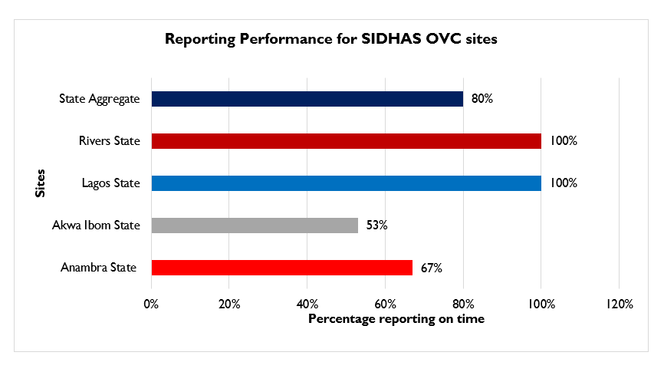

#### AREAS FOR IMPROVEMENT

* Untimely submission of reports from SIDHAS state offices and CBOs in Anambra and Akwa Ibom states.

#### RECOMMENDATIONS

* Ensure compliance of states and CBOs to reporting timelines.

# ACTION PLAN FOR SIDHAS OVC

A suggested action plan for the various SIDHAS OVC levels visited is outlined below, Table 8 – central level action plan, Table 9 - state level action plan, and Table 10 - CBO level action plan.

## ACTION PLAN FOR SIDHAS OVC CENTRAL LEVEL

Table 8. Action Plan for SIDHAS OVC Central Level

|  |  |  |  |
| --- | --- | --- | --- |
| AREAS FOR IMPROVEMENT | DESCRIPTION OF ACTION POINT | RESPONSIBLE | TIMELINE |
| Untimely submission of reports from states to the central office. | Monitor the reporting frequency of state office reports and ensure compliance of state offices to reporting timelines. | SIDHAS Director M&E | Before SIDHAS Activity close-out |

## ACTION PLAN FOR SIDHAS OVC STATE LEVEL

Table 9. Action Plan for SIDHAS OVC State Level

|  |  |  |  |
| --- | --- | --- | --- |
| AREAS FOR IMPROVEMENT | DESCRIPTION OF ACTION POINT | RESPONSIBLE | TIMELINE |
| Few charts developed using OVC indicator data at the SIDHAS Akwa Ibom state office. | Develop and disseminate findings from analyzed data to key stakeholders using OVC indicator data (in Akwa Ibom state). | SIDHAS Akwa Ibom state M&E officer | Before SIDHAS Activity close-out |
| Arrangement of beneficiary folders in horizontal position instead of the vertical position made retrieval difficult (HFFPD and SHERO CBOs). | Provide capacity building to CBO staff on the proper arrangement of beneficiary folders for easy retrieval (HFFPD and SHERO CBOs). | SIDHAS Lagos and Akwa Ibom state TO M&E | Before SIDHAS Activity close-out |
| Use of outdated VC service forms by CBOs in Akwa Ibom state. | Discourage the use of outdated VC service forms and encourage the use of only updated OVC reporting tools across all CBOs in Akwa Ibom state. | SIDHAS Akwa Ibom state TO M&E | Before SIDHAS Activity close-out |
| Errors observed during cross checks. | * Improve supervisory efforts with the CBOs to ensure accurate data entry and proper use of the NOMIS. * Conduct refresher training for CVs on completion of service forms and DECs on the NOMIS software. * Ensure all CBOs conduct data quality cross checks between NOMIS soft copy data and a hard copy Excel NOMIS data before reporting. * Provide support to CBO M&E officers to conduct periodic folder audits to resolve discrepancies observed during cross checks. | SIDHAS state TO M&E | Before SIDHAS Activity close-out |

## ACTION PLAN FOR SIDHAS OVC CBO LEVEL

Table 10. Action Plan for SIDHAS OVC CBO Level

|  |  |  |  |
| --- | --- | --- | --- |
| AREAS FOR IMPROVEMENT | DESCRIPTION OF ACTION POINT | RESPONSIBLE | TIMELINE |
| Numerous cancellations on service forms with correction fluid at CBOs in Akwa Ibom state. | Provide refresher training to CBO CVs in Akwa Ibom state on how to properly fill data collection tools. | M&E Officers of the SIDHAS CBOs in Akwa Ibom | Before SIDHAS Activity close-out |
| Inconsistent data back-up at SHERO CBO | Ensure consistent monthly data back-up at SHERO CBO. | SHERO CBO M&E Officer | Before SIDHAS Activity close-out |

# Limitations and Constraints

1. DQAs at a country level are complex exercises and require significant resources and effort on the part of the commissioning agency, the agency conducting the DQA, IPs, and government functionaries in the relevant sectors. As mentioned in USAID’s “How-To Note: Conduct a DQA,” notification of an impending DQA can also cause stress for the IP, given the ramifications of activity performance and the potential uncertainty of USAID’s expectations. Although the MEL Activity DQA team tried to allay initial apprehensions of the IP and its staff about the outcomes from the DQA, there may have been residual concerns that could not be fully addressed. The DQA team emphasized to the IP that subsequent to completion and dissemination of the final report, the DQA results are intended to be a tool for USAID and the IP to work together, to resolve any data quality issues or limitations discovered during the exercise.

2. The sampling of the four SIDHAS states (Akwa Ibom, Anambra, Lagos and Rivers), as well as the CBO sites sites visited in the states, was based on a purposive methodology, with consideration to security and feasibility issues, and was also guided by USAID. The ideal sampling methodology would have been to use a statistically valid scientific method, as described in the MEASURE Evaluation DQA guidelines. Implementation of a statistically valid method was constrained by security and other eligibility considerations outlined in section 3.1. This was partially compensated for by the number of CBOs covered during the DQA.

3. To ensure adequate time for the DQA teams in the field to complete all aspects of the DQA, including the M&E systems assessment, review of the data quality standards, data verifications, and cross-checks, a limited number of cross-checks were performed at each CBO (service delivery level). At most CBOs, at least twenty beneficiary folders were reviewed during the cross-checks. As described in detail in section 3.4.2, this limitation was partially addressed by using random selection of beneficiary folders (where feasible) from all household folders for the two reported quarters. Also, cross-checks were attempted in two directions—i.e., ten records were traced from the beneficiary forms/household folders to the NOMIS, and an additional ten unique beneficiary records were traced from the NOMIS back to the beneficiary folders for cross-verification.

# CONCLUSION

From the USAID/Nigeria and PEPFAR perspective, the DQA for OVC indicators serves to meet the operational policy requirements of USAID/Washington and USAID/Nigeria. It also serves to review the M&E system, identify best practices, and develop recommendations to improve existing systems, for better reporting of program indicators in subsequent funding cycles.

The M&E systems’ areas of strength across the three SIDHAS OVC levels assessed include the availability of trained M&E staff with clearly assigned responsibilities, availability of a data management SOP that guides M&E processes and the availability and use of the PEPFAR indicator reference guide. Recommendations for the areas that require improvement include improved supervisory efforts at the service delivery level; ensure compliance to SIDHAS M&E guidelines across all levels; ensure the use of only updated data collection tools; and provide training and support to the CVs to ensure proper filling of the data collection tools.

With reference to the ADS 201 definition of data quality standards (Table 1), the OVC_SERV and OVC_HIVSTAT indicator data reported by SIDHAS can be judged valid. The overall IP verification factor average was 100 percent, which falls within the +/- ten percent acceptable variance for determining the accuracy of verified data. The validity of the data for the two indicators can be improved by strengthening supervisory efforts at the state offices and CBO as well as the data review process at the CBO. Data was also found to be reliable, precise and have integrity. Timeliness can be improved by ensuring compliance of state and CBO levels to reporting timelines.

# Annexes

## LIST OF SITES VISITED AND LOCATIONS: SIDHAS OVC DQA

Table 3 (p. 12) provides a complete list of the sites and locations that were visited for the SIDHAS OVC DQA.

## STEPS FOR DATA VERIFICATION USING THE MEASURE EVALUATION TOOL

Figure 14. Tracing & Verifying Reported Totals: CBO via State to Central M&E Unit

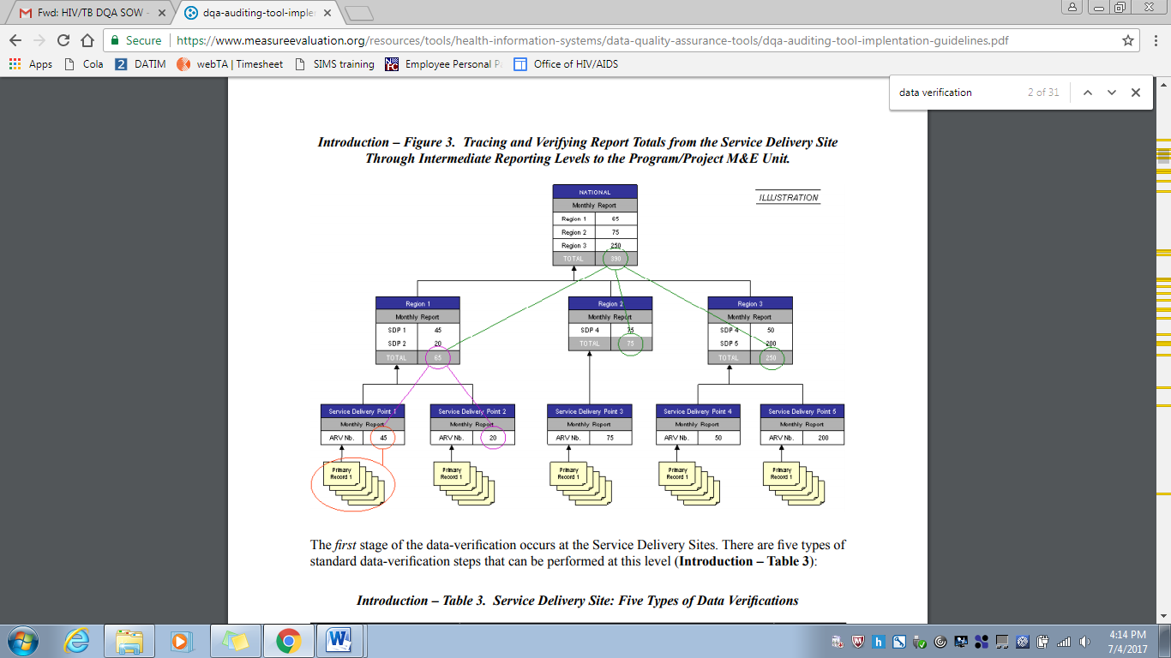

Source: MEASURE Evaluation (2008

## VERIFICATION FACTORS FOR SIDHAS OVC CENTRAL, STATE AND CBO LEVELS

Table 11. Verification Factors - OVC_SERV at SIDHAS OVC Central Level

|  |  |
| --- | --- |
| Level / Name | SIDHAS Central M&E Unit |
| **OVC_SERV** |
| Verified Data | 74,566 |
| Reported Data | 74,566 |
| Verification Factor (%) | 100% |

Table 12. Verification Factors - OVC_SERV at SIDHAS OVC State and CBO levels

|  |  |  |  |  |  |  |
| --- | --- | --- | --- | --- | --- | --- |
| S NO | TYPE OF LEVEL | NAME OF LEVEL | STATE/LGA | VERIFIED DATA | REPORTED DATA | VERIFICATION FACTOR (%) |
| 1 | State level | SIDHAS State Office | Anambra | 443 | 443 | 100% |
| 2 | State level | SIDHAS State Office | Akwa Ibom | 19,798 | 19,797 | 100% |
| 3 | State level | SIDHAS State Office | Lagos | 5,740 | 55,740 | 100% |
| 4 | State level | SIDHAS State Office | Rivers | 12,466 | 12,466 | 100% |
| 5 | CBO | Be Glad Foundation | Anambra/Anambra East & Ayamelum | 443 | 443 | 100% |
| 6 | CBO | WOCLIF Etinan | Akwa Ibom/Etinan | 1402 | 1402 | 100% |
| 7 | CBO | WOCLIF Uyo | Akwa Ibom/Uyo | 5395 | 5395 | 100% |
| 8 | CBO | SHERO | Akwa Ibom/ Ikot Ekpene | 5356 | 5356 | 100% |
| 9 | CBO | BLYSN | Lagos/Kosofe | 54 | 54 | 100% |
| 10 | CBO | JAKIN | Lagos/Ajeromi Ifelodun | 2462 | 2452 | 100% |
| 11 | CBO | HFFPD | Lagos/Agege | 421 | 421 | 100% |
| 12 | CBO | SMDI | Rivers/Ikot Ekpene | 7,302 | 7,302 | 100% |
| 13 | CBO | YPF Obio akpo | Rivers/ Obio Akpo | 2710 | 2710 | 100% |
| 14 | CBO | YPF Eleme | Rivers/ Eleme | 2341 | 2341 | 100% |

Table 13. OVC_HIVSTAT Numerator Total and Disaggregate Data at the Central, State and CBO Levels

|  |  |  |  |  |  |  |  |  |  |
| --- | --- | --- | --- | --- | --- | --- | --- | --- | --- |
|  |  | VERIFIED DATA | | | | REPORTED DATA | | | |
| SITE NAME | **STATE/LGA** | **A: Reported HIV positive to IP** | **B: Reported HIV negative to IP** | **C: No HIV status reported to the IP** | **Total: A+B+C** | **A: Reported HIV positive to IP** | **B: Reported HIV negative to IP** | **C: No HIV status reported to the IP** | **Total: A+B+C** |
| FHI 360 Central Office | FCT | 1012 | 52093 | 1853 | 54,958 | 1012 | 52093 | 1853 | 54,958 |
| Anambra IP State Office | Anambra | 128 | 2814 | 5 | 2947 | 128 | 2814 | 5 | 2947 |
| Akwa ibom IP State Office | Akwa Ibom | 94 | 16992 | 295 | 17,381 | 94 | 16992 | 295 | 17,381 |
| Lagos IP State Office | Lagos | 105 | 3501 | 94 | 3,700 | 105 | 3501 | 94 | 3,700 |
| Rivers IP State Office | Rivers | 73 | 8831 | 0 | 8,904 | 73 | 8831 | 0 | 8,904 |
| Be GLAD Foundation | Anambra/Anambra East | 13 | 31 | 0 | 44 | 13 | 31 | 0 | 44 |
| Be GLAD Foundation | Anambra/Ayamelum | 10 | 129 | 0 | 139 | 10 | 129 | 0 | 139 |
| Women Community Livelihood Foundation (WOCLIF), Etinan | Akwa Ibom/Etinan | 2 | 1019 | 21 | 1,042 | 2 | 1019 | 21 | 1,042 |
| Women Community Livelihood Foundation (WOCLIF), Uyo | Akwa Ibom/Uyo | 34 | 4684 | 30 | 4,748 | 34 | 4684 | 30 | 4748 |
| Support Health Redemption Organization (SHERO) | Akwa Ibom/Ikot Ekpene | 20 | 4532 | 11 | 4,563 | 20 | 4533 | 11 | 4,564 |
| Blissful Life for Youth Society of Nigeria | Lagos/Kosofe | 0 | 29 | 0 | 29 | 0 | 29 | 0 | 29 |
| JAKIN NGO | Lagos/Ajeromi Ifelodun | 73 | 1456 | 37 | 1,566 | 73 | 1456 | 37 | 1,566 |
| Humanity Family Foundation for Peace and Development | Lagos/Agege | 7 | 325 | 4 | 336 | 7 | 325 | 4 | 336 |
| Support for Mankind Development Initiative | Rivers/Port Harcourt | 24 | 5207 | 0 | 5,231 | 24 | 5207 | 0 | 5,231 |
| Youth Pro-File, Obio Akpor | Rivers/Obio Akpor | 32 | 1933 | 0 | 1,965 | 32 | 1933 | 0 | 1,965 |
| Youth Pro-File,Eleme | Rivers/Eleme | 17 | 1597 | 0 | 1,614 | 17 | 1597 | 0 | 1,614 |

Table 14. Verification Factors: OVC_HIVSTAT Numerator Total and Disaggregate Data at the Central, State and CBO Levels

|  |  |  |  |  |  |
| --- | --- | --- | --- | --- | --- |
|  |  | VERIFICATION FACTORS | | | |
| SITE NAME | **STATE/LGA** | **A: Reported HIV positive to IP** | **B: Reported HIV negative to IP** | **C: No HIV status reported to the IP** | **Total: A+B+C** |
| FHI 360 HQ Office | FCT | 100% | 100% | 100% | 100% |
| Anambra IP State Office | Anambra | 100% | 100% | 100% | 100% |
| Akwa ibom IP State Office | Akwa Ibom | 100% | 100% | 100% | 100% |
| Lagos IP State Office | Lagos | 100% | 100% | 100% | 100% |
| Rivers IP State Office | Rivers | 100% | 100% | 100% | 100% |
| Be GLAD Foundation | Anambra/Anambra East | 100% | 100% | 100% | 100% |
| Be GLAD Foundation | Anambra/Ayamelum | 100% | 100% | 100% | 100% |
| Women Community Livelihood Foundation (WOCLIF), Etinan | Akwa Ibom/Etinan | 100% | 100% | 100% | 100% |
| Women Community Livelihood Foundation (WOCLIF), Uyo | Akwa Ibom/Uyo | 100% | 100% | 100% | 100% |
| Support Health Redemption Organization (SHERO) | Akwa Ibom/Ikot Ekpene | 100% | 100% | 100% | 100% |
| Blissful Life for Youth Society of Nigeria | Lagos/Kosofe | 100% | 100% | 100% | 100% |
| JAKIN NGO | Lagos/Ajeromi Ifelodun | 100% | 100% | 100% | 100% |
| Humanity Family Foundation for Peace and Development | Lagos/Agege | 100% | 100% | 100% | 100% |
| Support for Mankind Development Initiative | Rivers/Port Harcourt | 100% | 100% | 100% | 100% |
| Youth Pro-File, Obio Akpor | Rivers/Obio Akpor | 100% | 100% | 100% | 100% |
| Youth Pro-File,Eleme | Rivers/Eleme | 100% | 100% | 100% | 100% |

## DATA BACKUP MECHANISMS IN ANAMBRA, AKWA IBOM, LAGOS AND RIVERS CBOS

Table 15. Data Backup Mechanisms Utilized in SIDHAS CBOs Visited

|  |  |  |  |  |  |  |  |  |  |  |  |  |
| --- | --- | --- | --- | --- | --- | --- | --- | --- | --- | --- | --- | --- |
| Name of CBO | State | Backup Mechanism Utilized | | | | | | | |  |  | Timeline |
| **Cloud Based** | | | | **Hard Drive** | **Flash Drive** | **Official Laptops /desktops** | **Personal devices** | **C. drive** | **E-Mail** |  |
| **Unspecified** | **One Drive** | **Google Drive** | **Drop Box** |  |  |  |  |  |  |  |
| GLAD | Anambra | √ |  |  |  |  |  |  |  |  |  | Monthly |
| WOCLIF Etinan | Akwa Ibom |  |  |  |  | √ |  |  |  |  |  | Monthly |
| WOCLIF Uyo | Akwa Ibom |  |  |  |  | √ |  |  |  |  |  | Monthly |
| SHERO | Akwa Ibom |  |  |  |  | √ |  |  |  |  |  | Monthly |
| BLYSN | Lagos |  |  |  |  | √ |  | √ |  |  | √ | Weekly  Monthly |
| JAKIN | Lagos |  |  |  | √ | √ |  |  |  |  | √ | Weekly  Monthly |
| HFFPD | Lagos |  |  |  |  | √ (stolen) |  | √ |  |  | √ | Weekly  Bi-weekly |
| SMDI | Rivers |  |  |  |  | √ |  |  |  |  |  | Weekly |
| YPF (Obio Akpo) | Rivers |  |  |  |  | √ |  |  |  |  |  | Weekly |
| YPF (Eleme) | Rivers |  |  |  |  | √ |  |  |  |  |  | Weekly |

## DIAGRAMMATIC REPRESENTATION OF CROSS-CHECKS AT CBO LEVEL

Figure 15. Methodology for Cross-Checks at CBO Level

**OVC CROSS CHECK AT CBO**

CROSS CHECK 1

CROSS CHECK 2

Select 10 Enrollment numbers and unique identifiers within the Reporting Period from NOMIS

Select 10 Beneficiary Service Forms (randomly where feasible) within the Reporting Period from 10 Folders (Using Enrollment Number and Unique Identifiers)

Confirm enrollees in NOMIS have 10 corresponding service forms

Confirm 10 enrollees are present on the NOMIS

Trace and Find Corresponding Entries and Compare in the NOMIS

Trace and Find Corresponding Entries and Compare in the Service Forms

## PERFORMANCE INDICATOR REFERENCE SHEET (PIRS)

Table 16: Performance Indicator Reference Sheet for OVC_SERV

|  |  |  |  |  |  |
| --- | --- | --- | --- | --- | --- |
| |  | | --- | | **OVC_SERV** | | | | | |
| Description: | Number of beneficiaries served by PEPFAR OVC programs for children and families affected by HIV | | | |
| Numerator: | Number of beneficiaries served by PEPFAR OVC programs for children and families affected by HIV | | The numerator is the sum of the following Program participation disaggregation:  1. Active beneficiaries  2. Graduated beneficiaries | |
| |  | | --- | | Denominator: | | N/A | | | |
| Changes in indicator: | Clarifying language added to this indicator reference sheet. Only OVC that actually received services in the past three months should be counted in this indicator. OVC that have registered for the program but have not yet received any services should not be counted in the results (MER 2.0 v2.1 to v2.2).  The disaggregation for program participation status has been clarified to capture types of beneficiaries: (1) active beneficiaries and (2) graduated beneficiaries, (MER 2.0 v2.2 Revised Release).  Beneficiaries that transferred or exited without graduation should no longer be reported in the numerator (MER 2.0 v2.2 Revised Release). However, these data will still be collected as disaggregates.  All indicator changes will be reflected in the data entry screens in DATIM beginning in FY 18 Q2 (MER 2.0 v2.2 Revised Release).  The transferred disaggregation was split into two separate disaggregation’s: transferred out to a PEPFAR-supported partner and transferred out to non-PEPFAR supported partner (MER 2.0 v2.2 Revised Release).  Indicator calculation is updated. Indicator returns to being a snapshot indicator again for FY 18 reporting. Results should not be summed across reporting periods (MER 2.0 v 2.2 Revised Release). | | | |
| How to use: | PEPFAR is mandated to care for children orphaned or made vulnerable by HIV. Mitigating the impact that HIV is having on children and the families that support them is integral to a comprehensive HIV response. It is important to note that the definition of “affected” children includes, but is not limited to, children infected with HIV. PEPFAR recognizes that individuals, families, and communities are affected by HIV in ways that may hinder the medical outcomes of HIV-positive persons as well as the emotional and physical development of children orphaned or made vulnerable by HIV/AIDS. A variety of services (per Technical Considerations 2017) are supported through PEPFAR to mitigate these effects in order to improve health and well-being outcomes of adults and children. The goal of OVC programs is to build stability and resiliency in children and families-exposed, living with or affected by HIV/AIDS through rigorous case management and provision and access to health and socio-economic interventions. This indicator, by disaggregating “active” and “graduated” in the numerator and collecting additional disaggregates for “transferred out to a PEPFAR-supported partner”, “transferred out to a non-PEPFAR supported partner”, and “exited without graduation” measures how successful the OVC program is in building children and their families’ resiliency. | | | |
| How to collect: | The data sources are the PEPFAR OVC program registers and program data generated by implementing partners. Implementing partners’ registers need to record names of children and caregivers who meet the criteria for “active beneficiary” or “graduated” to generate the numerator total included in this indicator. In addition, implementing partners should record whether children or caregivers “transferred out to a PEPFAR-supported partner”, “transferred out to a non-PEPFAR supported partner”, and “exited without graduation.”  All agencies receiving HKID funding are required to report on this indicator.  This indicator is a direct (output) measure of the number of individuals receiving PEPFAR OVC program services for children and families affected by HIV/AIDS and tracks progress on the number of OVC graduating from PEPFAR OVC programs and tracks “exited without graduation” (such as loss-to-follow up, aging out without transition plan, moved, or died). Transferred to existing host-country programs, where the host-country program provides a sustainable response to OVC needs. Transferred to existing PEPFAR-supported programs to track movement of children and caregivers between PEPFAR-supported partners. Graduation will vary based on local criteria for achieving stability in the household. | | | |
| Reporting level: | Facility & Community | | | |
| How often to report: | Semi-Annual | | | |
| How to review for data quality: | Reviewing PEPFAR OVC implementing partners’ results to ensure that there is no double counting and changes by Program Completion Status do not show high deviations from program targets and/or SNU prioritization (scale up, sustained, centrally supported, sustained commodities.  To ensure completeness, check that OVC_SERV total numerator (auto calculated based on participation status disaggregates) equals OVC_SERV results by age/sex disaggregates:  • OVC_SERV total numerator should equal OVC_SERV <1 + 1-9 + 10-14F + 10-14M + 15-17F + 15-17M + 18-24F + 18-24 M + 25+F + 25+M  • OVC_SERV total numerator should equal OVC_SERV<18 + OVC_SERV 18+  • OVC_SERV<18 = OVC_SERV <1 + 1-9 + 10-14F + 10-14M + 15-17F + 15-17M  • OVC_SERV 18+ = OVC_SERV 18-24F + 18-24 M + 25+F + 25+M | | | |
| How to calculate annual total: | To calculate data for annual results for OVC_SERV:  Sum Active (children and caregivers received services in the past three months) + Graduated (OVC that graduated from the OVC program in the past 12 months).  This indicator should be reported as a snapshot (i.e., report data as of the last day of the reporting period) in DATIM. | | | |
| Data elements (components of indicator): | Numerator:  Number of beneficiaries served by PEPFAR OVC programs for children and families affected by HIV. | Disaggregate Groups | | Disaggregates |
| Program Participation Status  [Required] | | * Active (Received at least one service in the past 3 months) * Graduated (At Q2: Report children and parents/ caregivers that graduated from the OVC program in the past 6 months. At Q4: Report children and parents/ caregivers that graduated from the OVC program in the past 12 months.) |
| Age/Sex (For Active and Graduated)  [Required]  Exited or Transferred [Required] Disaggregate should be reported for exited or transferred, even if no numerator (active + graduated) values are reported. | | * <1, 1-9, 10-14 M, 10-14 F, 15-17 M, 15-17 F, 18-24 M, 18-24 F, 25+ M, 25+ F * Transferred out to a PEPFAR-supported partner (At Q2: Report children and parents/caregivers that transferred out to a PEPFAR-supported partner in the past 6 months. At Q4: Report children and parents/caregivers that transferred out to a PEPFAR supported partner in the past 12 months.) * Transferred out to a non-PEPFAR supported partner (At Q2: Report children and parents/caregivers that transferred out to a non-PEPFAR-supported partner in the past 6 months. At Q4: Report children and parents/caregivers that transferred out to a non-PEPFAR supported partner in the past 12 months.) * Exited without graduation (At Q2: Report children and parents/caregivers that exited in the past 6 months. At Q4: Report children and parents/caregivers that exited in the past 12 months.) |
|  |  | Age/Sex/OVC Service Area  [DREAMS Conditional] | | * Education Support: <1, 1-9, 10-14 M, 10-14 F, 15-17 M, 15-17 F, 18-24 M, 18-24 F, 25+ M, 25+ F * Parenting/Caregiver Support: <1, 1-9, 10-14 M, 10-14 F, 15-17 M, 15-17 F, 18-24 M, 18-24 F, 25+ M, 25+ F * Social Protection: <1, 1-9, 10-14 M, 10-14 F, 15-17 M, 15-17 F, 18-24 M, 18-24 F, 25+ M, 25+ F * Economic Strengthening: <1, 1-9, 10-14 M, 10-14 F, 15-17 M, 15-17 F, 18-24 M, 18-24 F, 25+ M, 25+ F * Other Service Areas: <1, 1-9, 10-14 M, 10-14 F, 15-17 M, 15-17 F, 18-24 M, 18-24 F, 25+ M, 25+ F |
|  | Disaggregate Descriptions & Definitions | | | |
|  | Program Participation Status Definitions:   * “Active beneficiary” is an individual, a child, or parent/caregiver who has received at least one PEPFAR OVC program service in the last three months. New beneficiaries registered during the reporting period can be counted as active only if they have received at least one service in the last three months. Assessment, enrolment, case plan development, and case plan monitoring are not considered services. Please refer to the forthcoming OVC Reporting FAQ clarification on what activities constitute a service for more information. * “Graduation” is defined as:   1. Graduation is defined as happens when children and parent/caregivers enrolled in PEPFAR OVC programs are deemed stable and no longer in urgent need of externally supported services. Criteria for achieving stability in the household vary and should be defined at the OU-level to be consistent across IPs.  Or  2. Aging out: This only includes children who have reached the age of 18 and who have a transition plan for successful exiting from the PEPFAR OVC Program. This does not apply to children > 18 years old enrolled in secondary education.  Exited or Transferred Disaggregate Definitions:   * “Transferred out to a non-PEPFAR-supported partner” happens when children and families have transitioned to other forms of support programs other than PEPFAR funded OVC programs. These could include country-led programs or other donor funded programs. * “Transferred out to a PEPFAR-supported partner” happens when children and families have transitioned from the support of one PEPFAR partner to another PEPFAR-partner. * “Exited without graduation” This includes children and caregivers who are lost-to-follow up, re-located, or died and children who aged-out without a graduation plan from PEPFAR OVC program. | | | |
| PEPFAR-support definition: | Standard definition of DSD and TA-SDI used.  Provision of key staff or commodities for OVC beneficiaries receiving care and support services in the community include: For beneficiaries of OVC services, this can include funding of salaries (partial or full) for staff of the organization delivering the individual, small group or community level activity (e.g., psychosocial support, child protection services, education, etc.) or procurement of critical commodities essential for ongoing service delivery. Partial salary support may include stipends or incentives for volunteers or paying for transportation of those staff to the point of service delivery.  For care and support services, ongoing support for OVC service delivery for improvement includes: the development of activity-related curricula, education materials, etc., supportive supervision of volunteers, support for setting quality standards and/or ethical guidelines, and monitoring visits to assess the quality of the activity, including a home visit, a visit to a school to verify a child’s attendance and progress in school or observation of a child’s participation in kids clubs. | | | |
| Guiding narrative questions: | 1. What is the total achievement of OVC_SERV for <18 years and total numerator? Please explain partners with highest/lowest performance.  2. Please explain results by participation status disaggregate:  a. What criteria do beneficiaries need to achieve in order to graduate? Is that standard across partners in your OU?  b. How many beneficiaries exited without graduation? Please explain the reasons for exiting without graduation and try to quantify with percentages if possible. Are there certain partners with higher rates of exiting without graduation? How are you managing this with the partner(s)?  c. How many beneficiaries were transitioned? To whom (e.g., other NGOs, government support, etc.). Where were beneficiaries transferred? Please provide disaggregates for beneficiaries transferred to specific sources of support.  d. Of those who are reported to be active, what percentage is newly enrolled? Any re-enrollments of those LTFU? If yes, how many? Are any partners especially good at finding and re-enrolling those LTFU? | | | |

Table 17. Performance Indicator Reference Sheet for OVC_HIVSTAT

|  |  |  |  |  |
| --- | --- | --- | --- | --- |
| **OVC_HIVSTAT** | | | | |
| Description: | Percentage of orphans and vulnerable children (<18 years old) with HIV status reported to implementing partner (including report of no status). | | | |
| Numerator: | Number of orphans and vulnerable children (<18 years old) with HIV status reported to implementing partner, disaggregated by status type. | | Data sources for this indicator include HIV test results that are self-reported by OVC (or their caregivers), results of HIV Risk Assessments conducted by implementing partners, registers, referral forms, client records, or other confidential case management and program monitoring tools that track those in treatment and care. | |
| Denominator: | Number of orphans and vulnerable children reported under OVC_SERV (<18 years old) | | Denominator is not collected again, as part of this indicator but is collected under the indicator OVC_SERV. | |
| Changes in indicator: | • This indicator formerly called OVC_ACC (MER 1.0) and OVC_KNOWNSTAT (in the original MER 2.0 target setting documentation guidance) was changed to OVC_HIVSTAT to reflect that HIV status is self- reported to the implementing partner by the OVC or OVC caregiver (MER 1.0 to MER 2.0). | | | |
| How to use: | |  | | --- | | This indicator will be tracked through routine program monitoring semi-annually through the POART process.  Given the elevated risk of HIV infection among children affected by and vulnerable to HIV, it is imperative for PEPFAR implementing partners to monitor HIV status among OVC beneficiaries, and to facilitate access and retention in ART treatment for those who are HIV positive. When the implementing partner knows the HIV status, the program can contribute to ensuring that the children are linked to appropriate care and treatment services, all essential elements of quality case management. OVC programs can also play an important role in family-centered disclosure, for those who are HIV positive.  • This indicator is NOT intended to be an indicator of HIV tests performed or receipt of testing results, as these are measured elsewhere and test results are frequently unavailable to community organizations due to health facility concerns about patient confidentiality.  • This indicator is NOT intended to imply that all OVC beneficiaries require an HIV test. OVC with known positive or negative status do not need to be tested. Only OVC with no HIV status or children reported to be negative and recently experiencing sexual violence and/or other risk factors in the reporting period should be assessed for HIV risk. For older children who the IP thinks may be sexually active, they should be assessed every reporting period.  • Status disclosure to the implementing partner is NOT a prerequisite for enrollment or continuation in an OVC program. OVC programs serve persons of positive, negative, and unknown HIV status appropriate to their needs and vulnerability to HIV. This indicator ensures that IPs are regularly providing outreach to caregivers to identify children’s HIV status, encourage family disclosure and linkage to care and treatment as needed.  • This indicator captures if implementing partners are tracking the self-reported HIV status of the orphans and vulnerable children they serve and enrollment in ART for those who are positive. Testing results for OVC who are referred for testing should be reported under HTS_TST based on the service delivery point where they were tested  This indicator also captures if implementing partners are tracking if the orphans and vulnerable children they serve who report to be HIV positive are successfully linked to and retained in treatment and care.  • This indicator is a subset from OVC_SERV. Only OVC who were reported under OVC_SERV <18 should be included in the denominator for this indicator.  • Since this is not a testing indicator, HIV positivity yield should NOT be calculated based on this indicator. Yield calculations should only be made by testing partners. | | | | |
| How to collect: | Data sources for this indicator include HIV test results that are self-reported by OVC (or their caregivers), results of HIV Risk Assessments conducted by implementing partners, registers, referral forms, client records, or other confidential case management and program monitoring tools that track those in treatment and care.  Implementation of the HIV risk assessment should be integrated into case management and on-going case monitoring and should not be conducted separately, if possible. This will vary by partner and project. The partners should work out a timeline based on their experience of how long referral completion and status disclosure usually takes and factor that into their case management processes.  Implementing partners will record the OVC beneficiary’s self-reported HIV status –semi-annually. | | | |
| Reporting level: | Facility & Community | | | |
| How often to report: | Semi-Annual | | | |
| How to review for data quality: | The OVC_HIVSTAT total numerator should ideally equal OVC_SERV<18 results. In some cases, there may be missing data for the following reasons: 1) IP was not able to collect this information from all caregivers of OVC_SERV<18 within the reporting period, 2) IP was not able to locate all the caregivers of OVC_SERV<18 (e.g., relocated, migrant work), 3) data entry error and/or 4) Peace Corps is currently not reporting on this indicator so OVC served <18 under PC would be missing.  Review any site with the following reporting issues: 1) numerator greater than 100% of OVC_SERV <age 18, 2) very low coverage of OVC_HIVSTAT, 3) sum of “Currently on ART” and “Not currently on ART” do no equal the “Reported HIV positive to IP” results and 5) sum of “Test not indicated” and “Other reasons” do not equal “Reported No Status to IP”. | | | |
| How to calculate annual total: | Use result reported at Q4. | | | |
| Data elements (components of indicator): | Numerator:  Number of orphans and vulnerable children (<18 years old) with HIV status reported to implementing partner, disaggregated by status type. | Disaggregate Groups | | Disaggregates |
| Status Type  [Required] | | • Reported HIV positive to implementing partner  o Currently receiving ART  o Not currently receiving ART  • Reported HIV negative to implementing partner  • No HIV status reported to the implementing partner  o Test not indicated based on HIV risk assessment  o Other reasons |
| Disaggregate Descriptions & Definitions | | | |
| Status Type Disaggregate Definitions:  “Reported HIV Positive to IP”: includes beneficiaries <age 18 who report to the IP that they are HIV positive based on an HIV test conducted during or prior to the reporting period (regardless of where the test occurred). All entries for “reported HIV positive to IP” should be further disaggregated as “currently receiving ART” or “not currently receiving ART.” This also includes beneficiaries <age 18 who report that they are HIV positive based on an HIV test conducted during previous project reporting periods. OVC entered as “Reported HIV positive to IP” in the previous reporting period, should continue to be reported as positive during the current reporting period and their enrollment in ART noted.  • “Reported HIV negative to IP” includes beneficiaries <age 18 who report that they are HIV negative to the IP based on an HIV test conducted during the reporting period (regardless of where the test occurred). For a child who reports multiple tests within the current period, use most recent test. For beneficiaries entered as “Reported HIV negative to IP” in a previous reporting period—if the IP believes the child’s risk has not changed in the last six months, they should continue to report the child as negative during the current reporting period. However, if the IP believes that the child has recently been exposed to risk of HIV infection (e.g., sexual violence) or if an adolescent has become sexually active, then the IP should conduct the HIV risk assessment. Potential outcomes reported after the HIV risk assessment include 1) the child is tested and reported as HIV positive and either currently receiving ART or not receiving ART, or 2) the child is tested and reported as HIV negative, or 3) the child is reported as “No Status” and under one of its disaggregates (“Test not indicated” or “Other reasons”).  • “No HIV status reported to the IP” includes beneficiaries who fall into one of the below described categories:  • “Test not indicated” – includes beneficiaries (OVC_SERV<age 18) who based on a risk assessment made by the implementing partner do not require a test during the reporting period. (Consensus Conference Technical Report on the Role of OVC Programs Supported by PEPFAR in Extending Access to HTS includes further information on determining whether a test is indicated)  • “Other reasons” – includes all beneficiaries (OVC_SERV <age 18) not entered in above categories. Potential scenarios included in other reasons include:  i. Caregiver refuses to disclose whether the child has been tested and his/her current HIV status in the reporting period  ii. Caregiver refuses to let the IP conduct a risk assessment on the child in the reporting period.  iii. Caregiver recommended by IP to have child tested base on risk assessment, but refuses to test the child in the reporting period OR does take child to test but doesn't report results to IP in the reporting period.  iv. The IP is still in the process of convincing the caregiver to get the child assessed, tested and/or disclosure of status. Since this is a new indicator and takes time, IPs may not be positioned to report within the reporting period and would be captured under – Undisclosed to IP - Other Reasons. The IP should monitor these children and provide services to encourage referral completion and disclosure in the next reporting period.  • Children entered as “No HIV status reported to the IP” with the disaggregate “Other reasons” in the previous reporting period should receive follow-up services to encourage referral completion/disclosure of status to the IP. Children reported as “No HIV Status to the IP” with the disaggregate “Test not indicated” with no changes in their risk situation for past six months, don’t need to be reassessed. If the IP believes the child’s risk situation has changed in the last six months, then the child should be reassessed by the implementing partner to determine whether testing is indicated and the results entered as outline above, and the child should receive appropriate follow-up | | | |
| PEPFAR-support definition: | Standard definition of DSD and TA-SDI used.  Provision of key staff or commodities for OVC beneficiaries receiving care and support services in the community include: For beneficiaries of OVC services, this can include funding of salaries (partial or full) for staff of the organization delivering the individual, small group or community level activity (e.g., psychosocial support, child protection services, education, etc.) or procurement of critical commodities essential for ongoing service delivery. Partial salary support may include stipends or incentives for volunteers, or paying for transportation of those staff to the point of service delivery.  For care and support services, ongoing support for OVC service delivery for improvement includes: the development of activity-related curricula, education materials, etc., supportive supervision of volunteers, support for setting quality standards and/or ethical guidelines, and monitoring visits to assess the quality of the activity, including a home visit, a visit to a school to verify a child’s attendance and progress in school or observation of a child’s participation in kids clubs. | | | |
| Guiding narrative questions: | For OVC_HIVSTAT, if less than 100% of caregivers have reported their child's status, please explain the percentage that have not reported to the IP their child's status and the plan to get closer to 100% coverage. Are there certain partners that are struggling and how the Mission is responding?  2. For children reported as not currently on ART, what are efforts are being undertaken in response? Are there certain partners with low ART coverage, why?  3. Please explain the breakdown of those reported under No Status. What percentage were: 1) risk assessed and reported as test not indicated and 2) test indicated, 3) caregivers unwilling to disclose status; 4) incomplete referrals for testing; 5) Other reasons (please specify). | | | |

## LIST OF DOCUMENTS, DATA AND STANDARD OPERATING PROCEDURES REVIEWED

### LIST OF SIDHAS OVC DATA DOCUMENTS REVIEWED

1. SIDHAS CBO Submissions
2. SIDHAS State Report Submission
3. FY18 Semi Annual Program Report data – October 2017-March 2018

### LIST OF SIDHAS TOOLS REVIEWED

1. VC Enrollment Register
2. VC Enrollment Form
3. OVC Service Form
4. Child Follow Up Assessment Form
5. HIV Risk Assessment Form
6. HIV Test Results

### LIST OF SIDHAS SOP/GUIDELINES AND OTHER DOCUMENTS REVIEWED

1. Performance Indicator Reference Sheet (PIRS) – MER 2.0 V 2.2 updated release
2. M&E Training Reports
3. SIDHAS SOP for Data Management
4. SIDHAS Brief August 2018
5. Revised SIDHAS PMP
6. SIDHAS OVC Project Overview
7. Protocol for FY18 HIV OVC DQA
8. MEL Activity DQA Protocol
9. SIDHAS Presentation on OVC Service Delivery and Data Management – PowerPoint Presentation during the FY18 DQA training.

## LIST OF INDIVIDUALS INTERVIEWED DURING THE SIDHAS OVC DQA

Table 18. List of Individuals Interviewed during the SIDHAS OVC DQA

|  |  |  |  |  |  |
| --- | --- | --- | --- | --- | --- |
| S. No. | Name | Location | Title | State | Level |
| 1 | Tosin Idaboh | SIDHAS Abuja | Senior Technical Officer (STO) (OVC) | FCT | Central |
| 2 | Mmudu Rashidat | SIDHAS Abuja | STO referrals | FCT | Central |
| 3 | Onimode Bayo M | SIDHAS Abuja | Technical Officer (TO) GIS/Database | FCT | Central |
| 4 | Ochanya Asueumhen | SIDHAS Abuja | Assistant Director M&E | FCT | Central |
| 5 | Siaka Momoh | SIDHAS Abuja | STO M&E | FCT | Central |
| 6 | Onwuaduegbo Anaette | SIDHAS Abuja | Assistant Technical Officer (ATO) M&E | FCT | Central |
| 7 | Ismaila Sule | SIDHAS Abuja | ATO M&E | FCT | Central |
| 8 | Adedokun Sanmi | SIDHAS Abuja | Director M&E | FCT | Central |
| 9 | Abdul_Razak Omoaka | SIDHAS Abuja | M&E Assistant | FCT | Central |
| 10 | Saade Gustav Idem | SIDHAS, Rivers | Senior Program Officer (SPO) | Rivers | State |
| 11 | Gift Williams | SIDHAS, Rivers | SPO | Rivers | State |
| 12 | Ekele Oche David | SIDHAS, Rivers | STO-M&E | Rivers | State |
| 13 | Ngozi Adibe | SIDHAS, Rivers | TO-M&E | Rivers | State |
| 14 | Edochie Chijioke | SIDHAS, Rivers | TO-M&E | Rivers | State |
| 15 | Oyawola Babatunde | SIDHAS, Rivers | TO-M&E | Rivers | State |
| 17 | Juliet Azubuike | SIDHAS, Rivers | TO-P&M | Rivers | State |
| 18 | Iminabo Austen-Okoroafor | SMDI | Executive Director | Rivers | State |
| 19 | Belema Akpali Philip | SMDI | Program officer | Rivers | State |
| 20 | Adekunle Nelson | SMDI | M&E Assistant | Rivers | State |
| 21 | John Umo-Otong | YPF | Program co-ordinator | Rivers | State |
| 22 | Benedicta Bona | YPF | PROGRAM OFFICER | Rivers | State |
| 23 | Briggs-O Homa Nkesi | YPF | M&E | Rivers | State |
| 24 | Timothy Odeniyi | YPF | FINANCE/ADMIN | Rivers | State |
| 25 | Emmanuel Odo | YPF | M&E Assistant | Rivers | State |
| 26 | Chukwuma Anene | SIDHAS, Lagos | Senior Program Officer | Lagos | State |
| 27 | Iyaiya.A. Mutaltor | SIDHAS, Lagos | Technical Officer M&E | Lagos | State |
| 28 | Patrick Ikani | SIDHAS, Lagos | STO (PCT) | Lagos | State |
| 29 | Olabisi Mapadeun | SIDHAS, Lagos | Technical officer | Lagos | State |
| 30 | Opusolu Babatunde | SIDHAS, Lagos | State Program manager | Lagos | State |
| 31 | Nanji Ajayi | SIDHAS, Lagos | STO (PCT) | Lagos | State |
| 32 | Waleola Olubanjo | SIDHAS, Lagos | TO M&E | Lagos | State |
| 33 | Jane Akpobaro | SIDHAS, Lagos | TO M&E | Lagos | State |
| 34 | Agbebatu Williams | SIDHAS, Lagos | TA M&E | Lagos | State |
| 35 | Umar Nasir | SIDHAS, Lagos | TO-P&M | Lagos | State |
| 36 | Odegemba Chioma | BLYSN | M&E Officer | Lagos | State |
| 37 | Ukolo Jemicah | BLYSN | Assistant M&E Officer | Lagos | State |
| 38 | Akhigbe Juliet | BLYSN | Program Officer | Lagos | State |
| 39 | Okeke Collins O. | BLYSN | Program Manager | Lagos | State |
| 40 | Ogundiniyi Olufemi | BLYSN | Finance Officer | Lagos | State |
| 41 | Awugosi Obiagew | BLYSN | Executive Director | Lagos | State |
| 42 | Adenigba Henry O. | HFFPD | Executive Director Programmes | Lagos | State |
| 43 | Adeleye Adekemi | HFFPD | Executive Director/Finance & Admin | Lagos | State |
| 44 | Awe Aanuoluwapo | HFFPD | M&E Officer | Lagos | State |
| 45 | Bassey Aniema | HFFPD | Program Officer | Lagos | State |
| 47 | Onuoha Oluwunmi | HFFPD | Program Manager | Lagos | State |
| 48 | Omolara Odetade | Jakin NGO | M&E Officer | Lagos | State |
| 49 | Umar Nasir | SIDHAS, Lagos | TO-P&M | Lagos | State |
| 50 | Akinosho Olumide | Jakin | Project Officer Jakin | Lagos | State |
| 51 | Ijaiya A .M. | SIDHAS, Lagos | TO-M&E | Lagos | State |
| 52 | Ogunwale Abiodun | Jakin NGO | Project Officer | Lagos | State |
| 53 | Bala Gana | SIDHAS, Akwa Ibom | Technical Officer | Akwa Ibom | State |
| 54 | Okoli Maureen | SIDHAS, Akwa Ibom | Technical Assistance - M&E | Akwa Ibom | State |
| 55 | Nnamdi Ike | SIDHAS, Akwa Ibom | Technical Officer | Akwa Ibom | State |
| 56 | Emmanuel Mshelia | SIDHAS, Akwa Ibom | Technical Officer (P&M) | Akwa Ibom | State |
| 57 | Ijaiya. A. Mukhtar | SIDHAS, Akwa Ibom | Technical Officer - M&E | Akwa Ibom | State |
| 58 | Esther Ugoe | WOCLIF | Data Entry Clerk | Akwa Ibom | State |
| 59 | Udofia Edidem Uwem | WOCLIF | Data Entry Clerk | Akwa Ibom | State |
| 60 | Ephraim Dennis | WOCLIF | Program Officer | Akwa Ibom | State |
| 61 | Blessing Etuk | WOCLIF | Finance Officer | Akwa Ibom | State |
| 62 | Jackson Oyem | WOCLIF | Data entry Officer | Akwa Ibom | State |
| 63 | Ifiok Godfrey | WOCLIF | M&E officer | Akwa Ibom | State |
| 64 | Godwin William | WOCLIF | M&E officer | Akwa Ibom | State |
| 65 | Uduak Micheal Abia | SHERO | DEC | Akwa Ibom | State |
| 66 | Theresa Ibanga | SHERO | Finance officer | Akwa Ibom | State |
| 67 | Edidiong Ekong | SHERO | Program officer | Akwa Ibom | State |
| 68 | Monday Usen Ekpo | SHERO | Case manager | Akwa Ibom | State |
| 69 | Glory Felix Okon | SHERO | Case manager | Akwa Ibom | State |
| 70 | Umoh Effiong Edet | SHERO | Case manager | Akwa Ibom | State |
| 71 | Uduak R. Akpanken | SHERO | Case manager | Akwa Ibom | State |
| 72 | Edidiong Morgan Okpo | SHERO | Office Assistant | Akwa Ibom | State |
| 73 | John C. Iduagofh | SHERO | Program Manager | Akwa Ibom | State |
| 74 | Mmedara Mathew | SHERO | M&E | Akwa Ibom | State |
| 75 | Ogonnaya Kanu-Oji | SIDHAS Anambra | STO M&E | Anambra | State |
| 76 | Uju Eze | SIDHAS Anambra | TO Prevention/Mitigation | Anambra | State |
| 77 | Ekweaga Ngozi | SIDHAS Anambra | M&E VOL | Anambra | State |
| 78 | Mbah Francisca | SIDHAS Anambra | SNR. PROG.OFFICER | Anambra | State |
| 79 | Mmaduka Rosemary | GLAD | FINANCE OFFICER | Anambra | State |
| 81 | Ejie Daniel | GLAD | M&E OFFICER | Anambra | State |
| 82 | Okeke Nkemakolam | GLAD | P/O | Anambra | State |
| 83 | Juliana Nebeife | GLAD | MANAGER | Anambra | State |
| 84 | Iweajuzu Chidinma | GLAD | DEC | Anambra | State |
| 85 | Dibenta Nonye | GLAD | F/S | Anambra | State |
| 86 | Okechukwu Juliet | GLAD | V/S | Anambra | State |

1. MEASURE Evaluation. Data Quality Assurance Tools: DQA and RDQA Toolkit (Internet). Available from: <https://www.measureevaluation.org/resources/tools/health-information-systems/data-quality-assurance-tools>
2. ADS 201 Additional Help. USAID Recommended Data Quality Assessment (DQA) Checklist. Available from: <https://www.usaid.gov/sites/default/files/documents/1865/201sae.pdf>
3. MEASURE Evaluation. Data Quality Assurance Tools: DQA and RDQA Toolkit (Internet). Available from: https://www.measureevaluation.org/resources/tools/health-information-systems/data-quality-assurance-tools
4. ADS 201 Additional Help. USAID Recommended Data Quality Assessment (DQA) Checklist. Available from: <https://www.usaid.gov/sites/default/files/documents/1865/201sae.pdf>